
SCHOOL OF INFORMATICS & IT
DIPLOMA IN APPLIED ARTIFICIAL INTELLIGENCE
CLOUD TECHNOLOGIES FOR AI (CAI2C09)
AY2026/2027 APRIL SEMESTER
Project Report
Student Name (Matric Number) : KHIN PYAESONE WIN (2503083D)
Class Group : PC02
Tutor : JIN LEE
Submission Date : 17 August 2026

Contents
1 Introduction of Website 3
2 Services Used 13
3 Development of AWS Rekognition 14
4 Development of Additional AWS Services 21
5 Deployment Process 25
6 Setup Guide for AWS Services 33
7 Testing, Security and Validation 38
8 Conclusion and Future Improvements 40
9 References 41

1 Introduction of Website
1.1 Problem Statement
Polytechnics and universities can have damaged furniture, broken facilities, exposed electrical wiring, water leaks and other maintenance issues that may create safety risks for students and staff. A student may notice an issue but not know the correct person to contact, may forget to report it later, or may find the reporting process inconvenient. Information passed verbally through lecturers or staff can also be delayed before reaching the maintenance team.
NexSafe addresses this problem by providing a centralised, cloud-based reporting platform. Students can submit a photo, issue type, location and description from the website. Staff can review reports, assign priority, update progress and provide a visible staff update. The objective is to reduce reporting friction, improve visibility of campus hazards and make the path from discovery to resolution easier to track.
1.2 Website Overview
Item | NexSafe implementation
Website name | NexSafe - Smart Issue Reporting Platform
Final public URL | https://d2a0yi8f3vpirh.cloudfront.net/
Target users | Students and staff / administrators
Primary purpose | Report, verify, review, prioritise and track campus safety and maintenance issues
Video demonstration | https://youtu.be/iN1GmdFdWw8

Students sign in with their school account, create reports and track their own submissions. Staff accounts use a separate role-based interface with a review queue and management tools. Photo evidence is analysed by an AWS Rekognition Custom Labels model before submission for the five trained issue types. The final website is delivered using Amazon CloudFront with website files stored in Amazon S3.
1.3 Key Functional Features
• Role-based student and staff sign-in using Amazon Cognito group claims.
• Student report creation with title, issue type, building, level, exact location and description.
• Interactive Amazon Location map that records a student-selected latitude and longitude.
• Photo upload to Amazon S3 and AWS Rekognition Custom Labels verification before submission.
• Live report feed with category filtering for Safety Hazards, Maintenance Issues and Other.
• Student My Reports view with Submitted, Under Review, In Progress, Resolved and Rejected states.
• Staff Review Queue, priority selection, staff update messages and report deletion.
• Complete Create, Read, Update and Delete operations through API Gateway, Lambda and RDS MySQL.
• Amazon SNS notifications for new reports and student-facing report updates.
• Private S3 content delivered through CloudFront using bucket policies restricted to the distribution.
1.4 Overall AWS Architecture
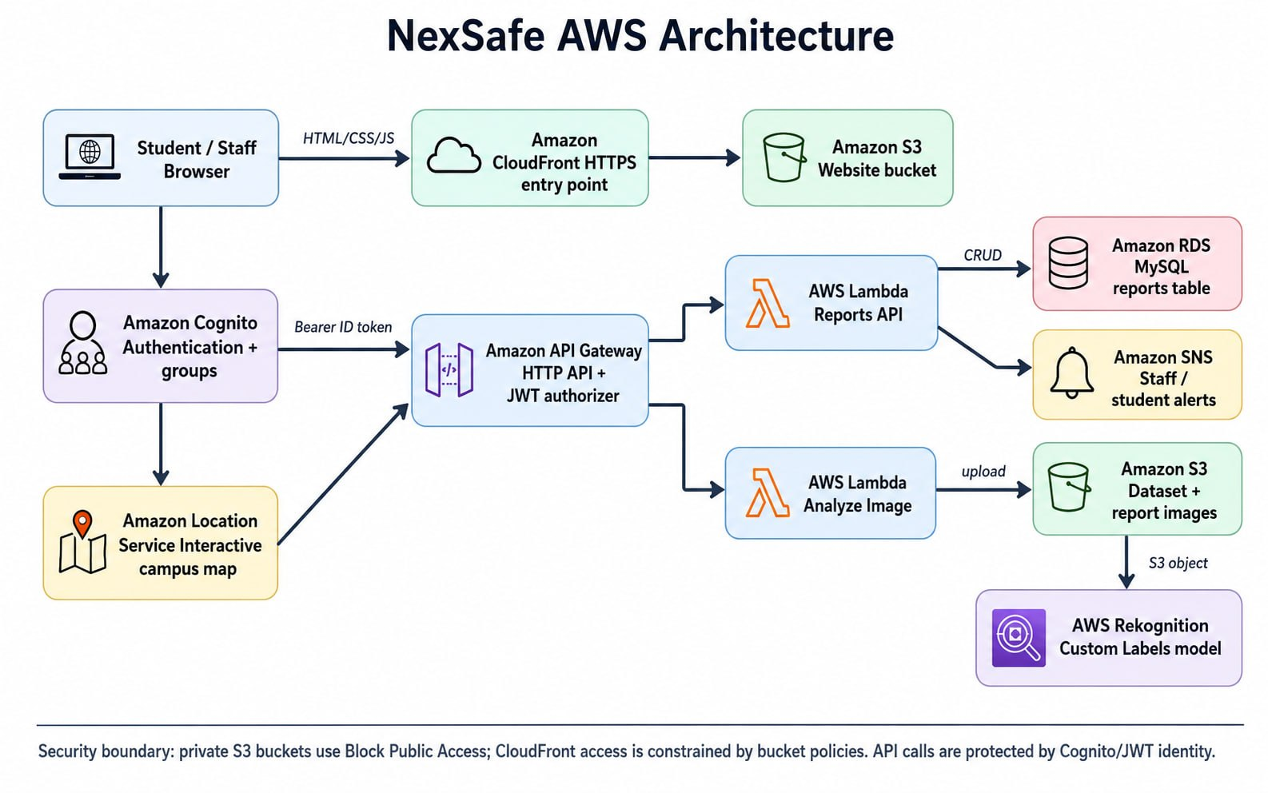
Figure 1. Overall NexSafe AWS architecture and main service interactions.
The architecture separates presentation, authentication, API processing, database storage and image analysis. The static front end is stored in S3 and accessed through CloudFront. Cognito establishes identity and role. Protected HTTP API requests are sent to API Gateway and routed to Lambda. Structured report data is stored in RDS MySQL; report images are stored in a separate S3 data bucket; AWS Rekognition reads the uploaded S3 object for custom-label inference. Amazon SNS is triggered by report creation or staff updates, and Amazon Location supports the interactive campus map.
1.5 Website Pages and User Workflow
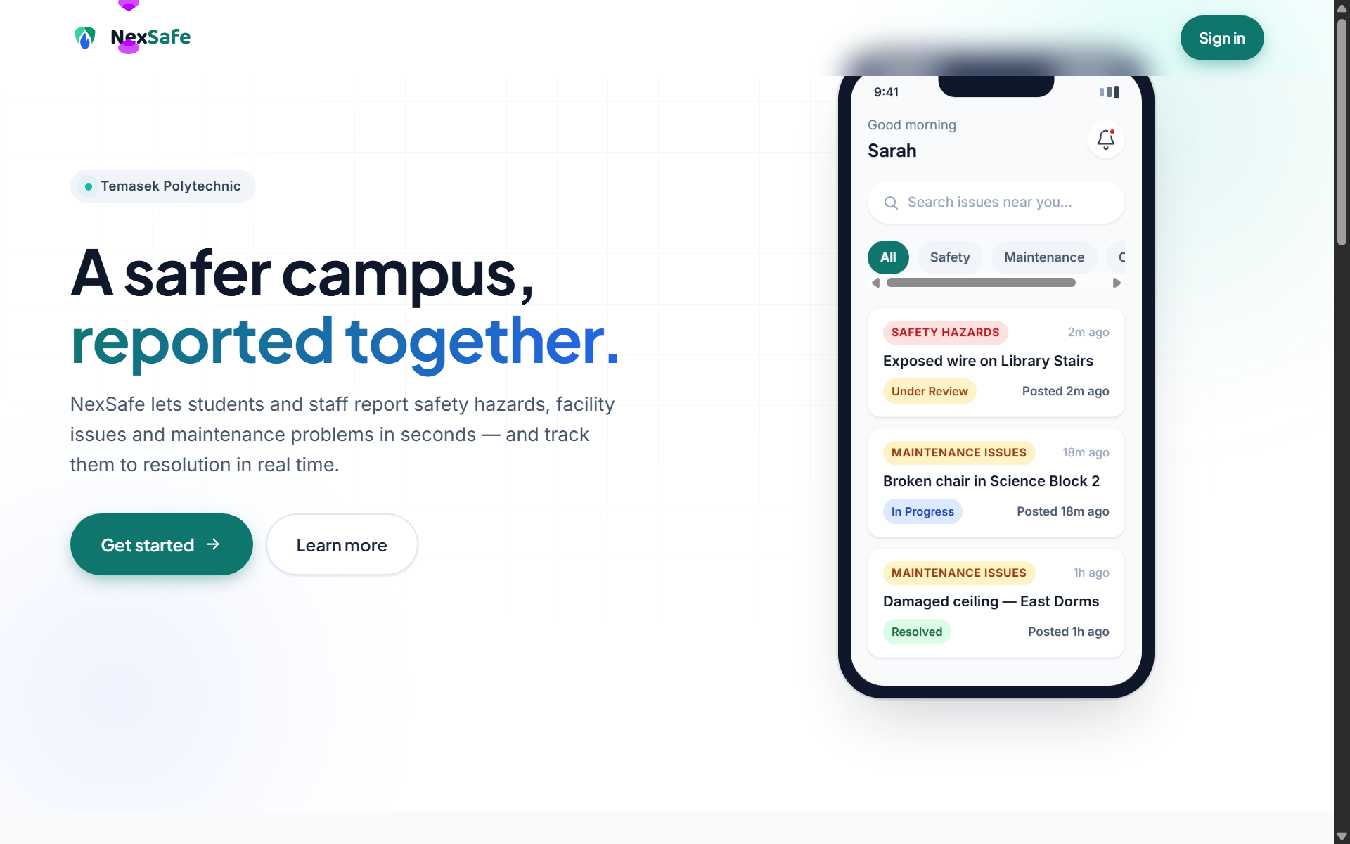
Figure 2. NexSafe public landing page and primary call to action.
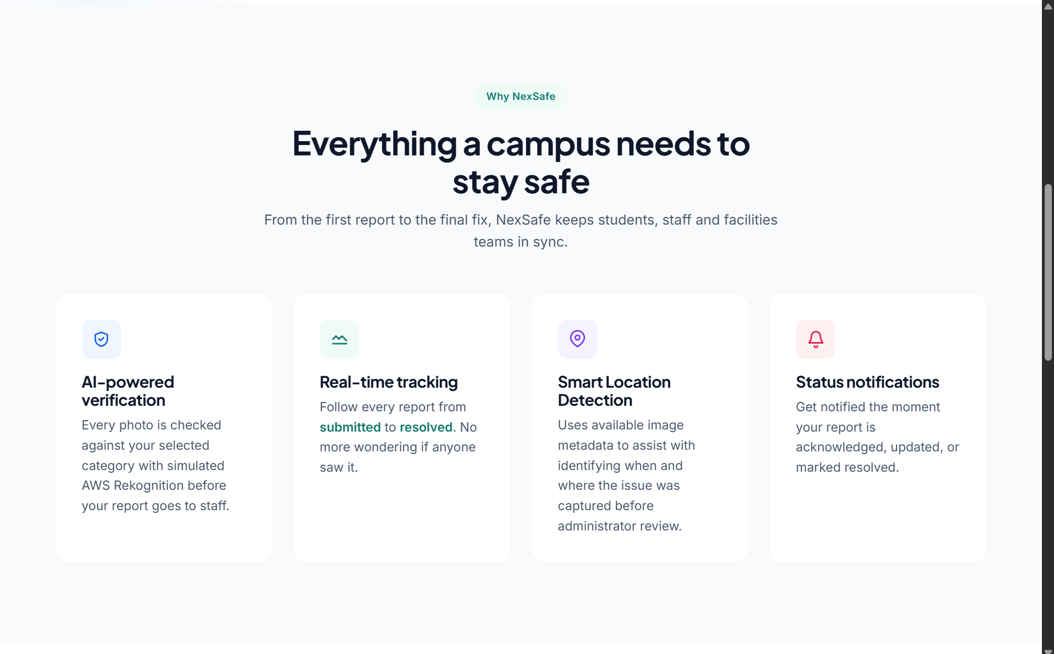
Figure 3. Landing-page feature overview.
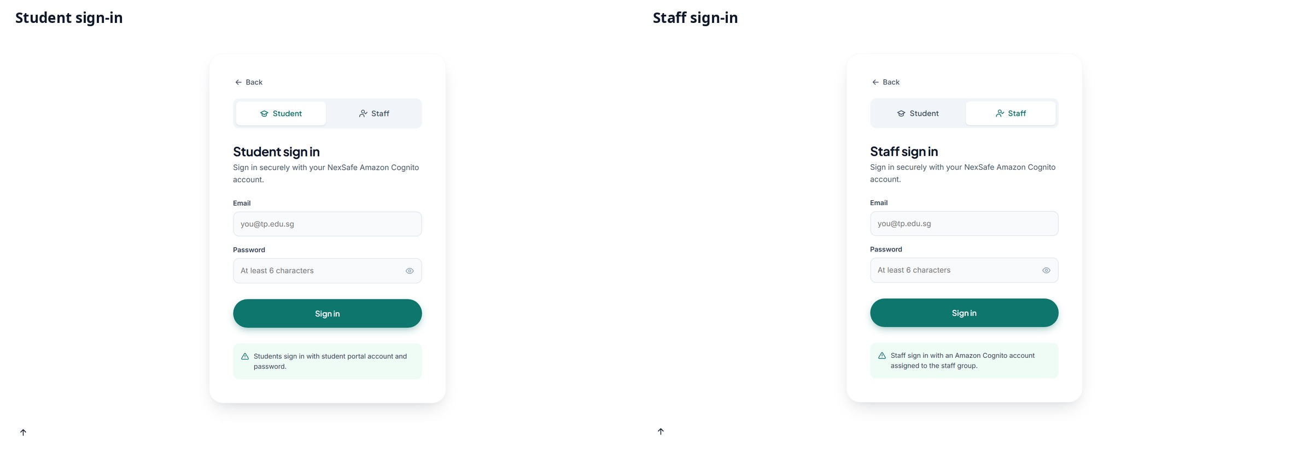
Figure 4. Student and staff sign-in interfaces.
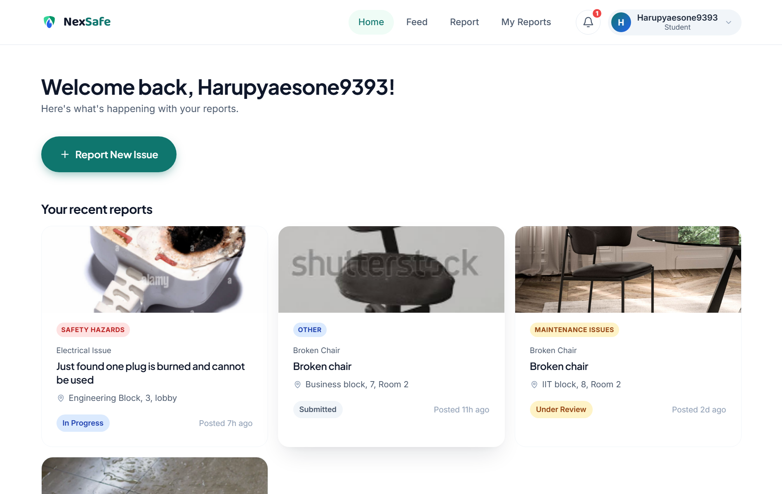
Figure 5. Student Home dashboard with recent reports and status indicators.
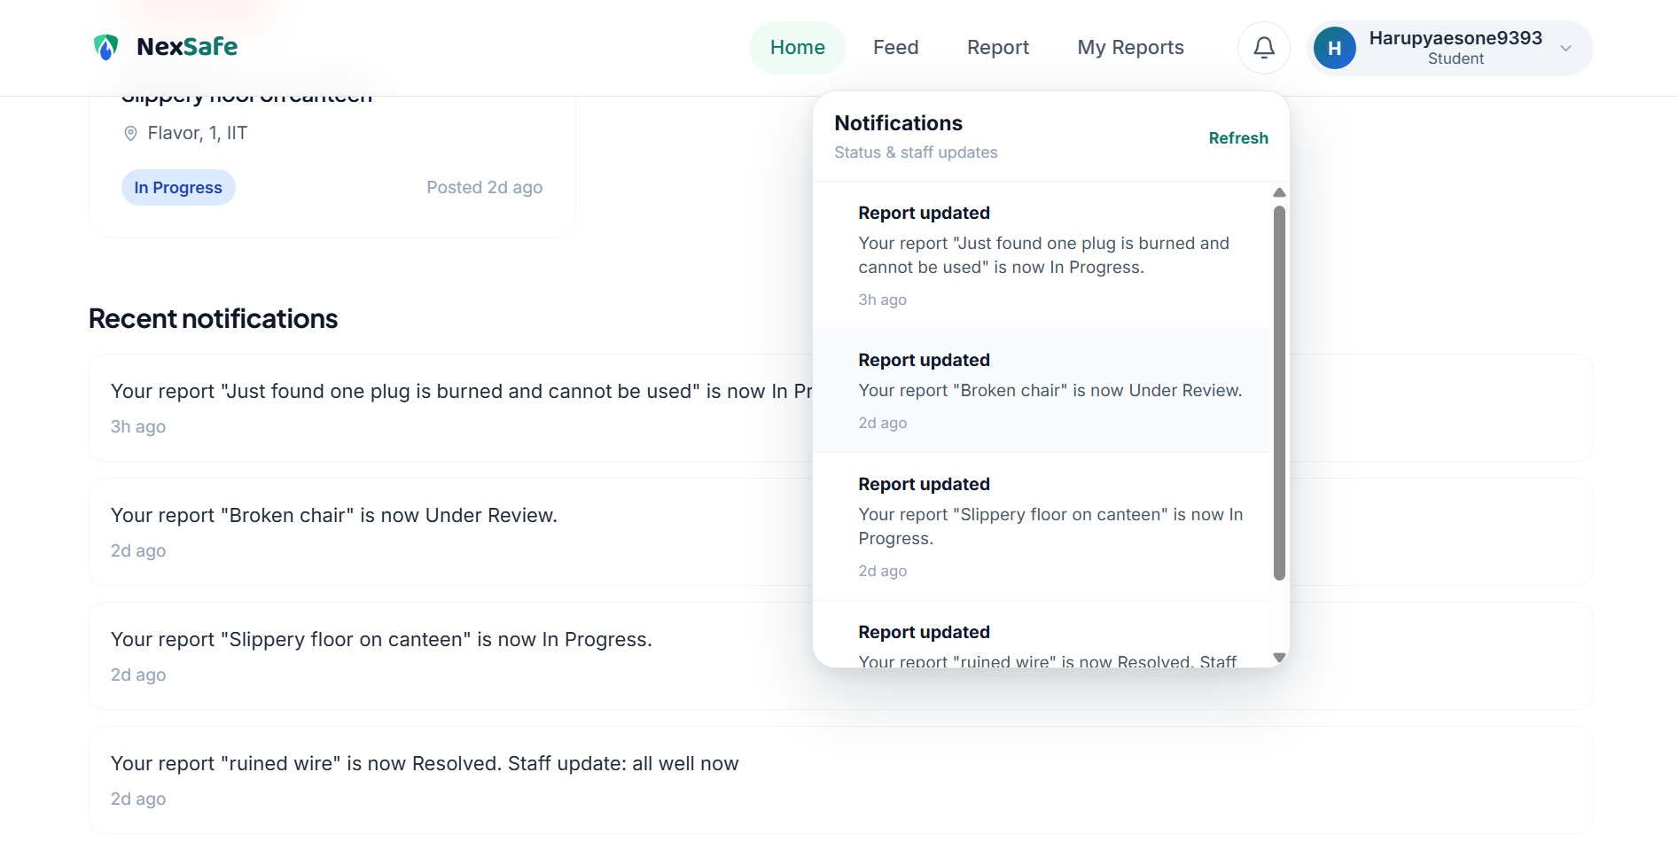
Figure 6. Student notification panel showing report status updates.
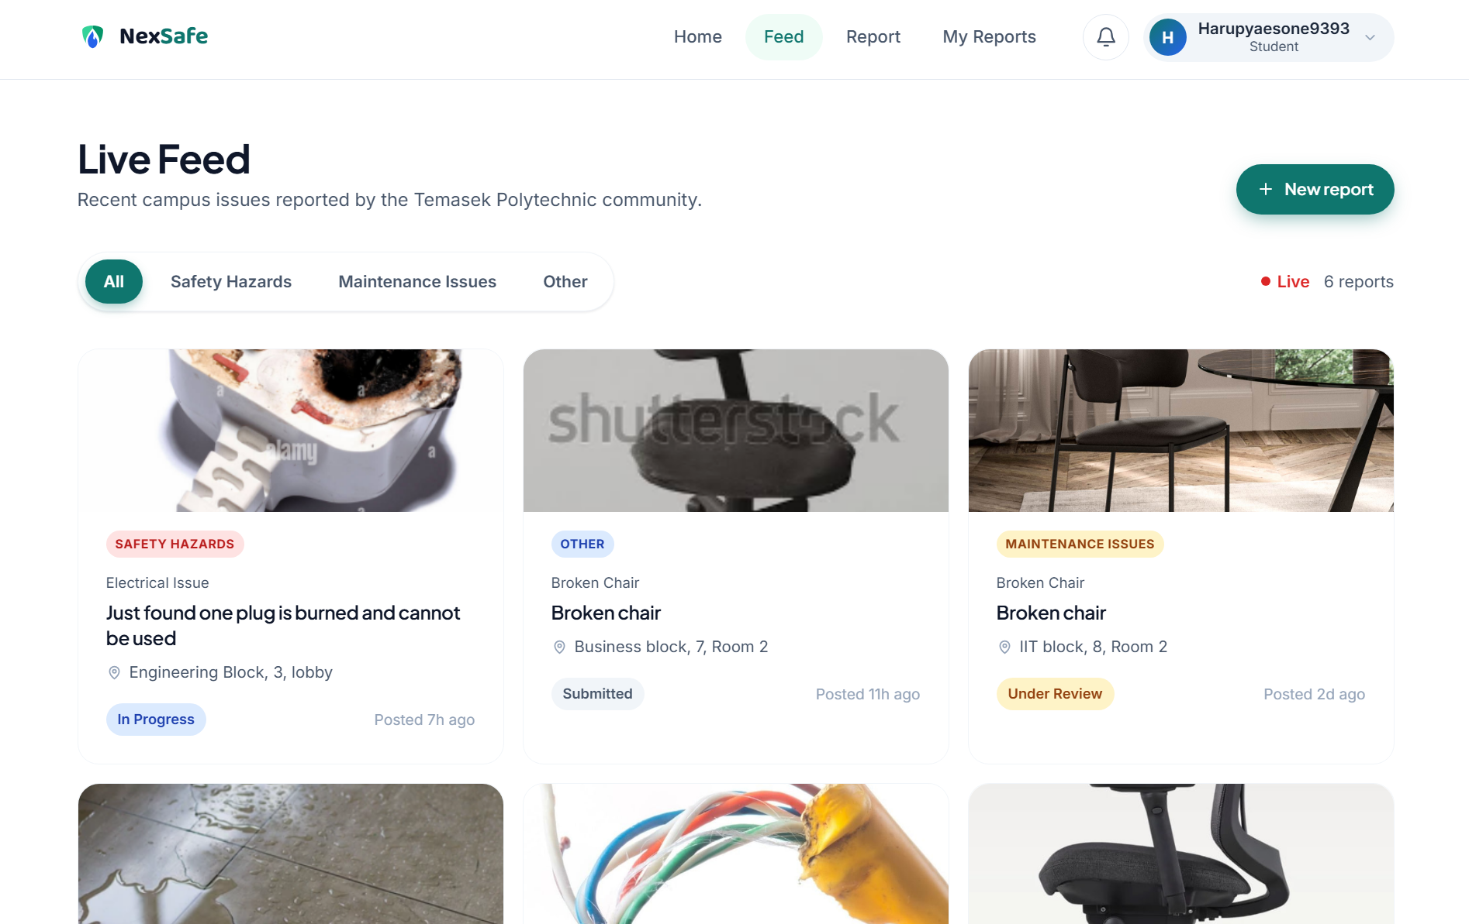
Figure 7. Live Feed page displaying reports from the campus community.
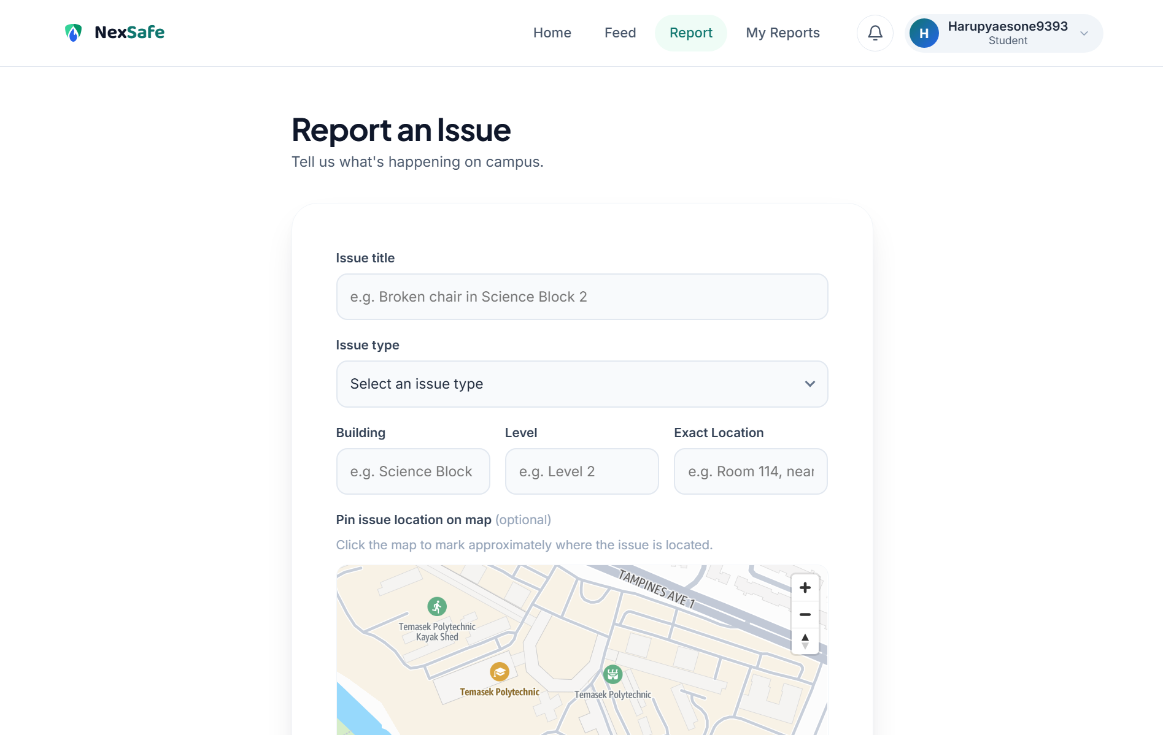
Figure 8. Report an Issue page with structured fields and Amazon Location map.
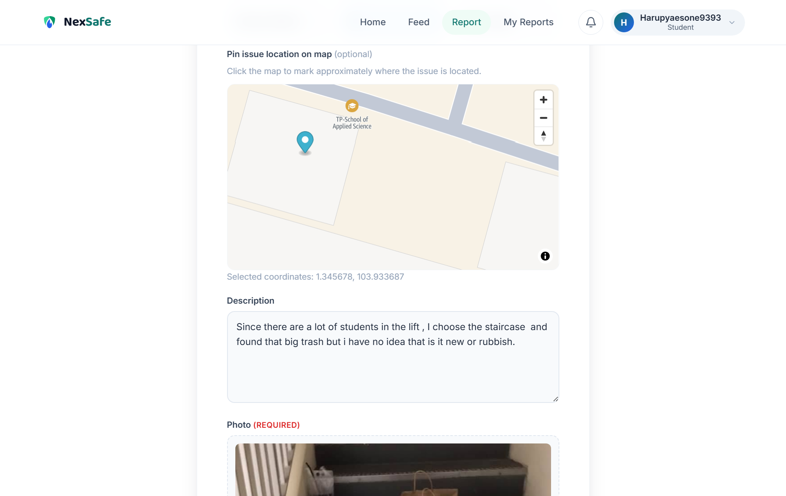
Figure 9. A student-selected map point and coordinates attached to a report.
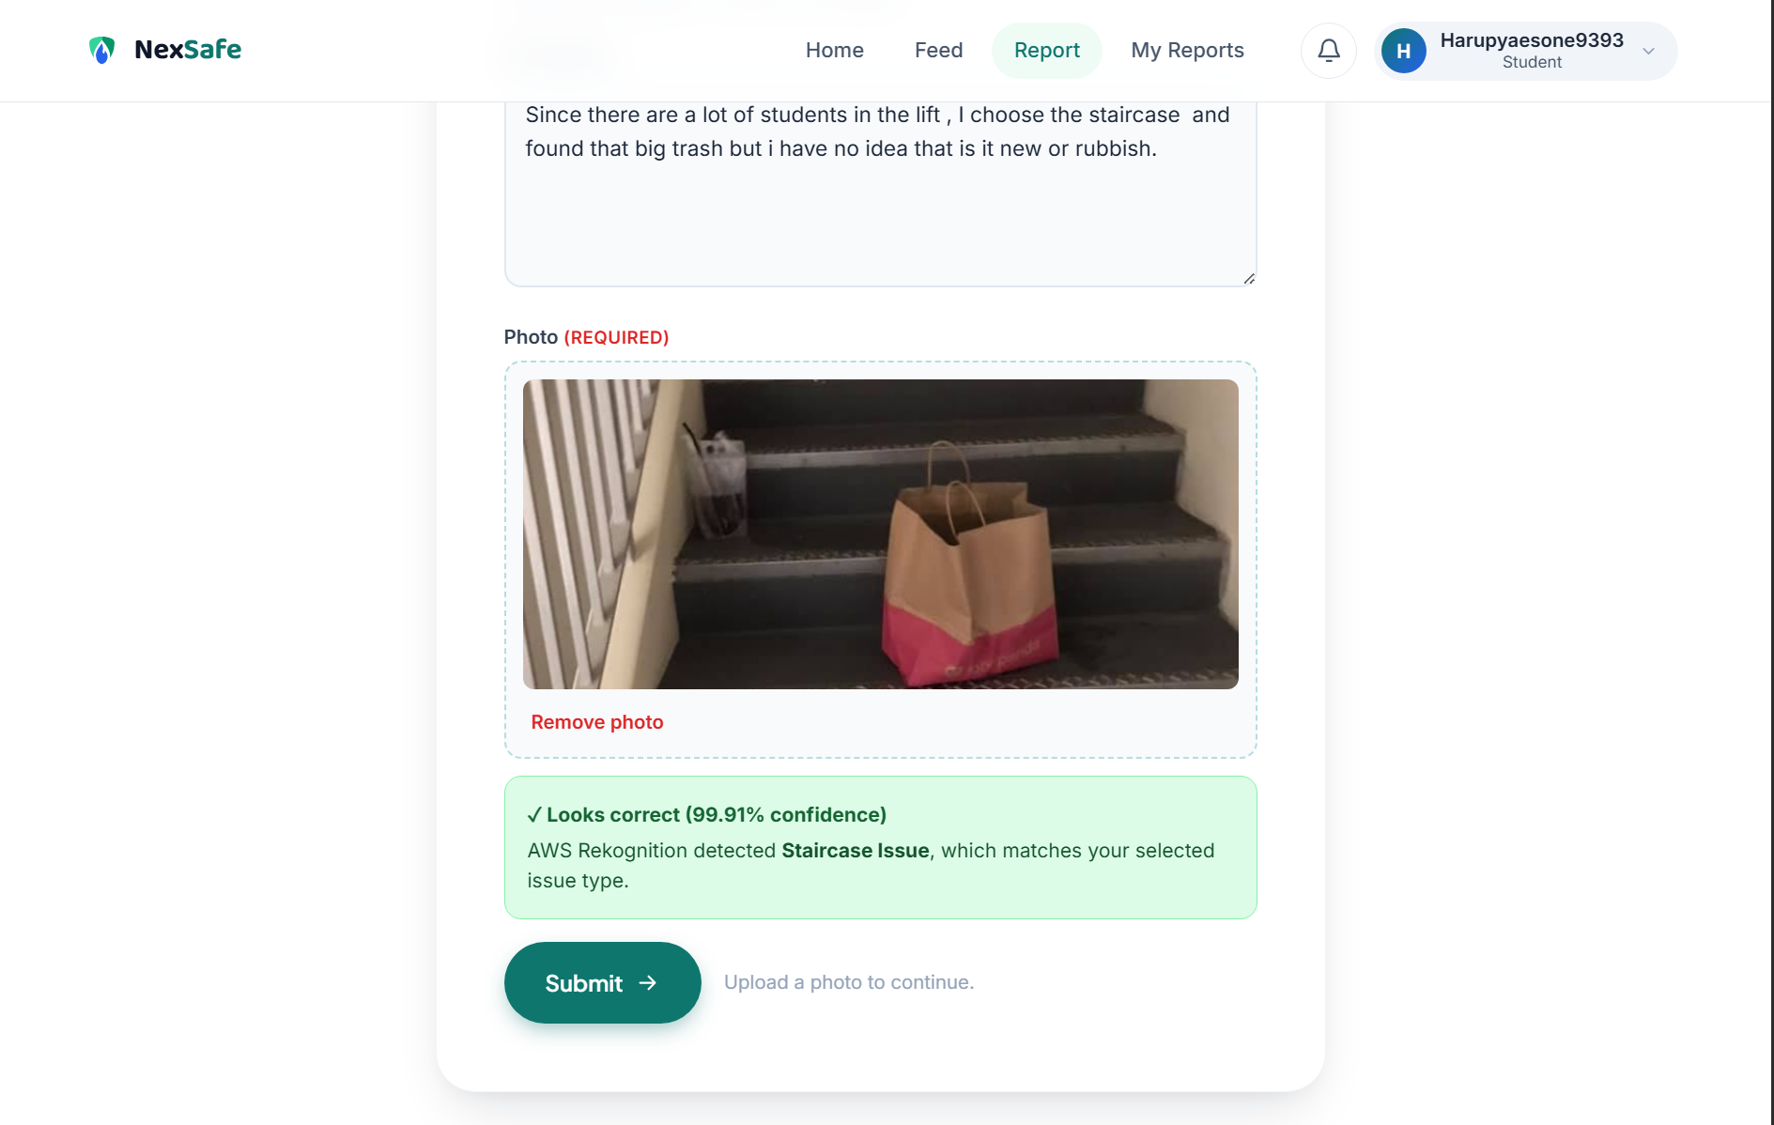
Figure 10. Real AWS Rekognition result: Staircase Issue matched at 99.91% confidence.
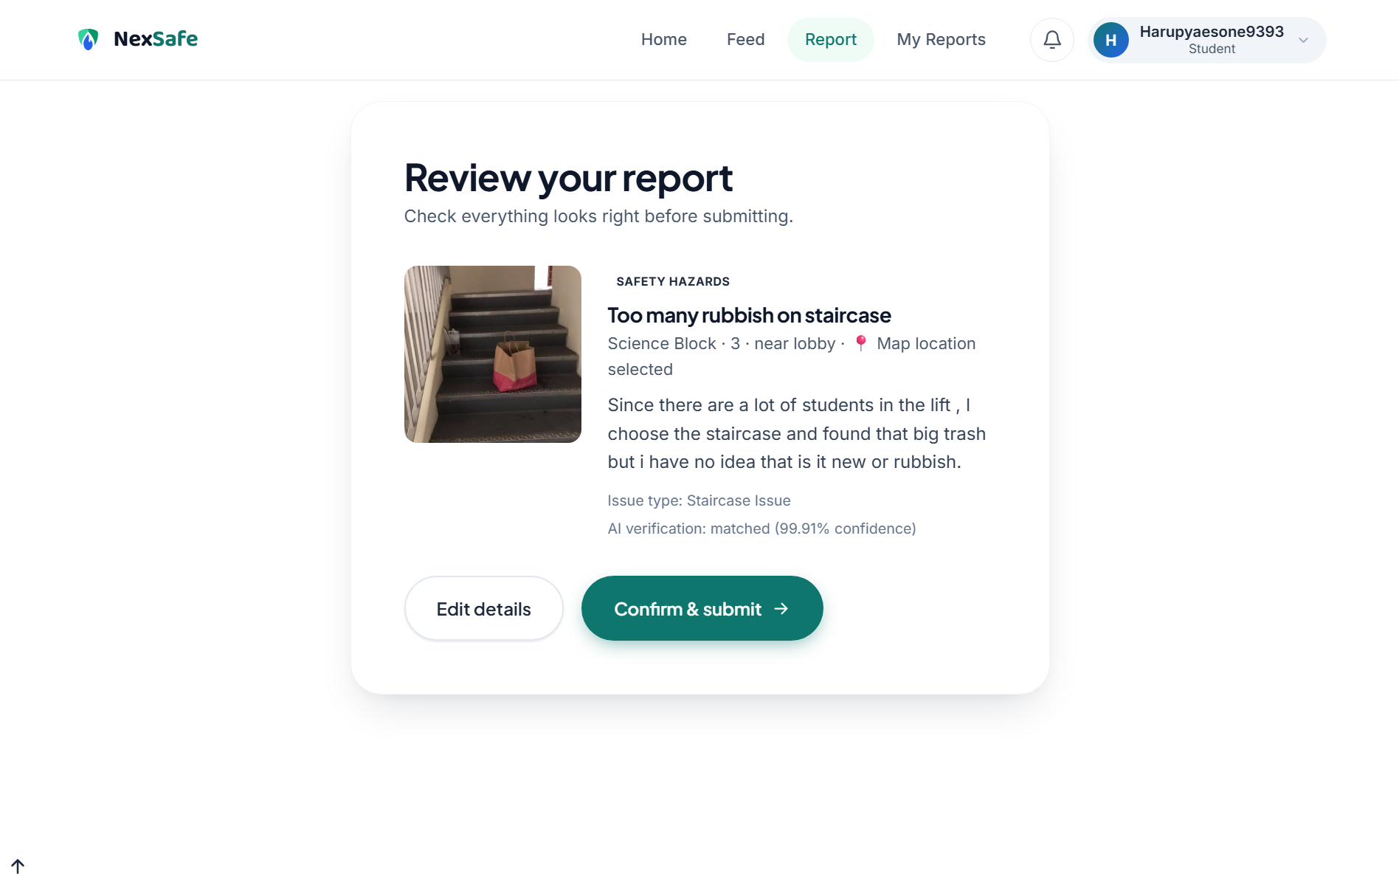
Figure 11. Final student review screen before the report is committed.
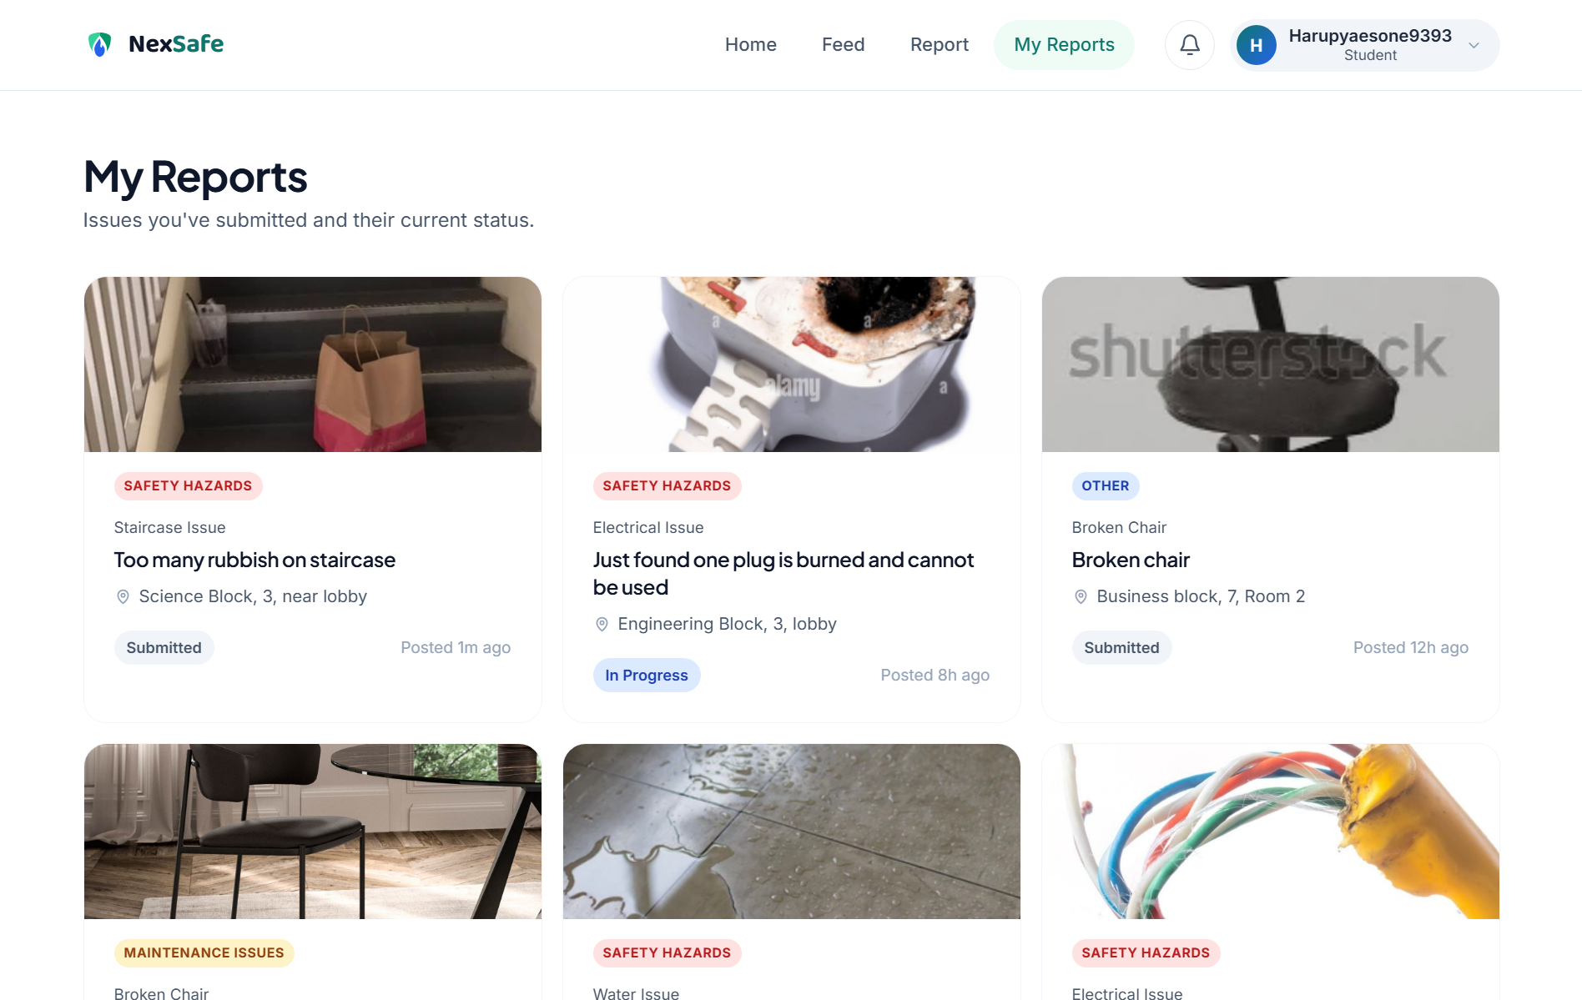
Figure 12. My Reports page showing the student's submitted items and current states.
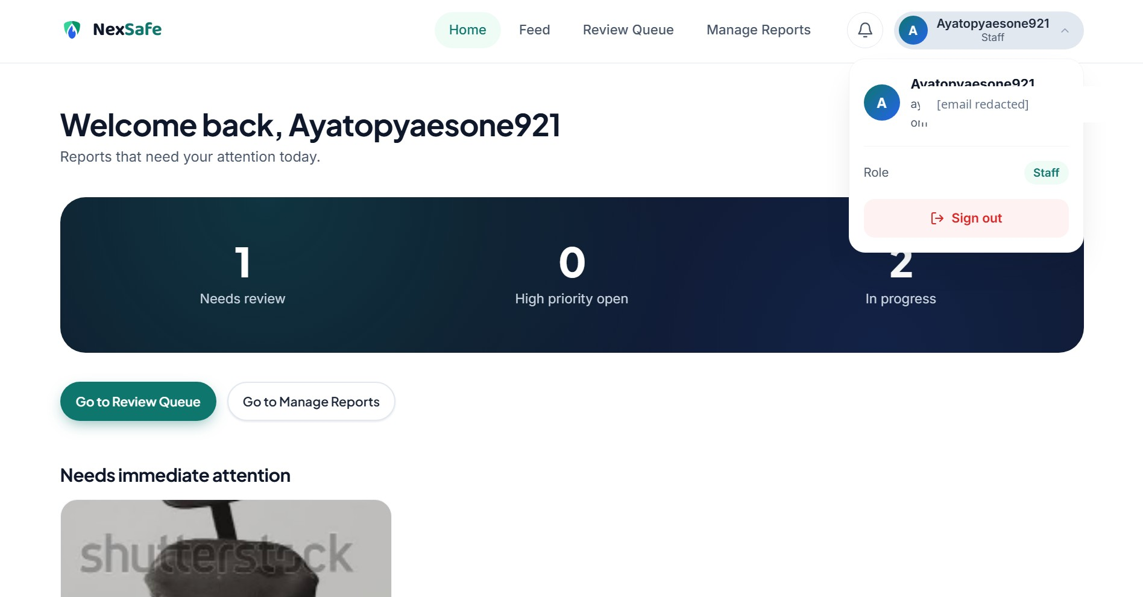
Figure 13. Staff Home dashboard with role information and operational counters (email redacted).
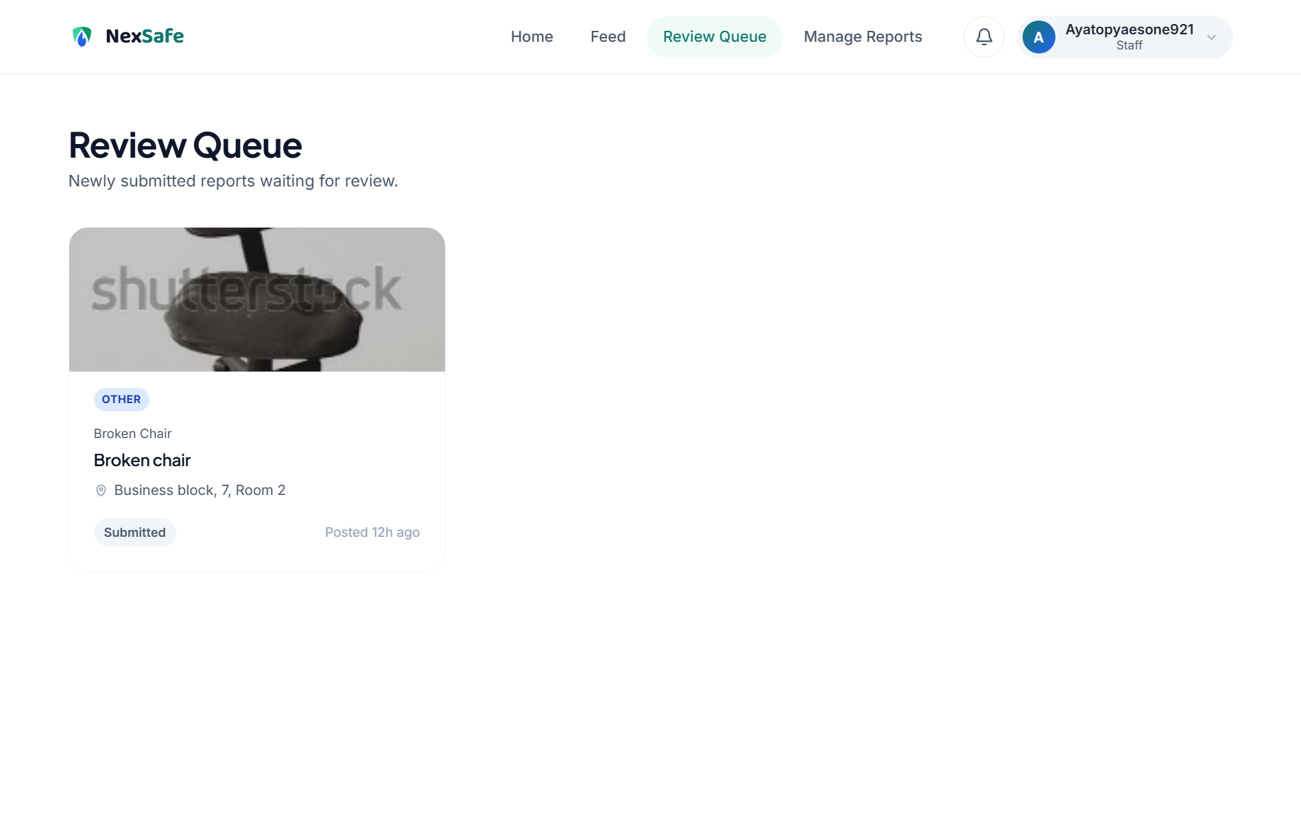
Figure 14. Staff Review Queue for newly submitted reports.
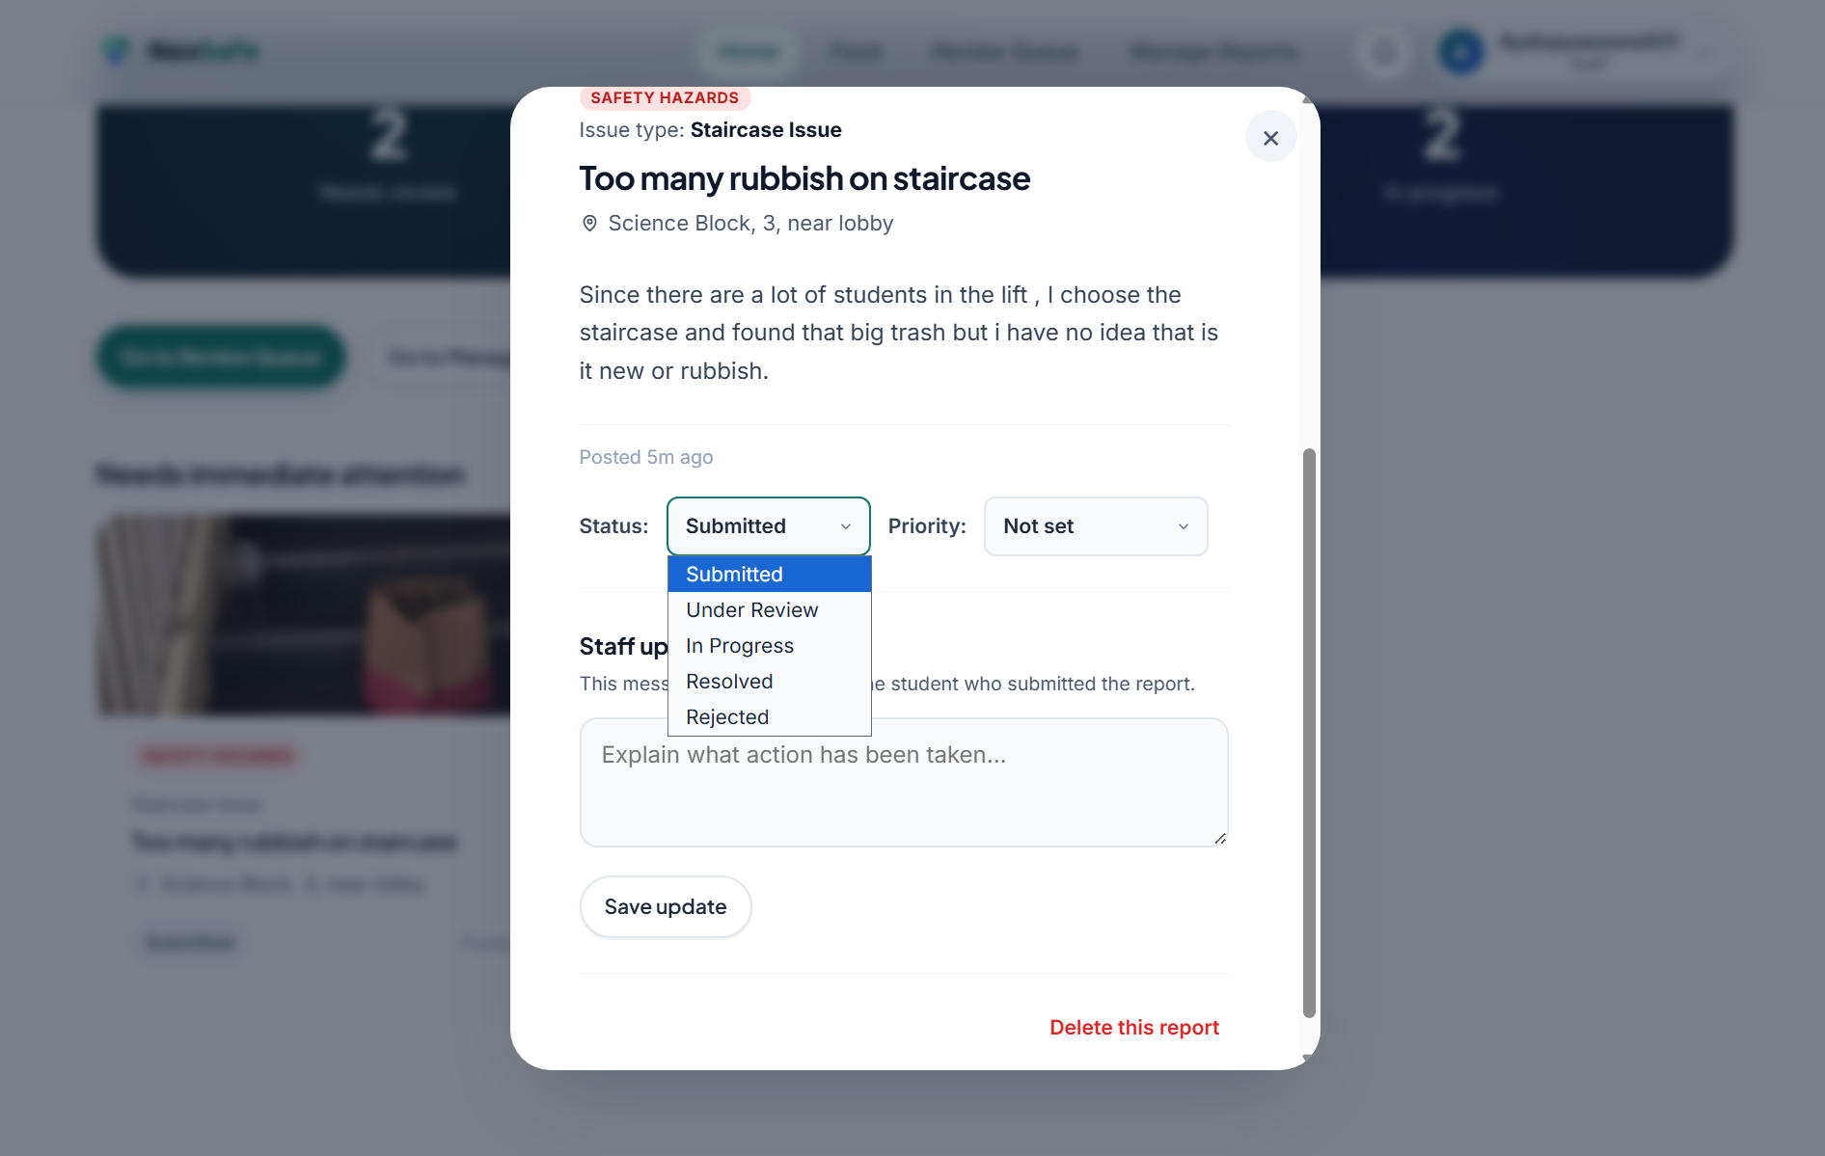
Figure 15. Staff report editor with status control and staff-only actions.
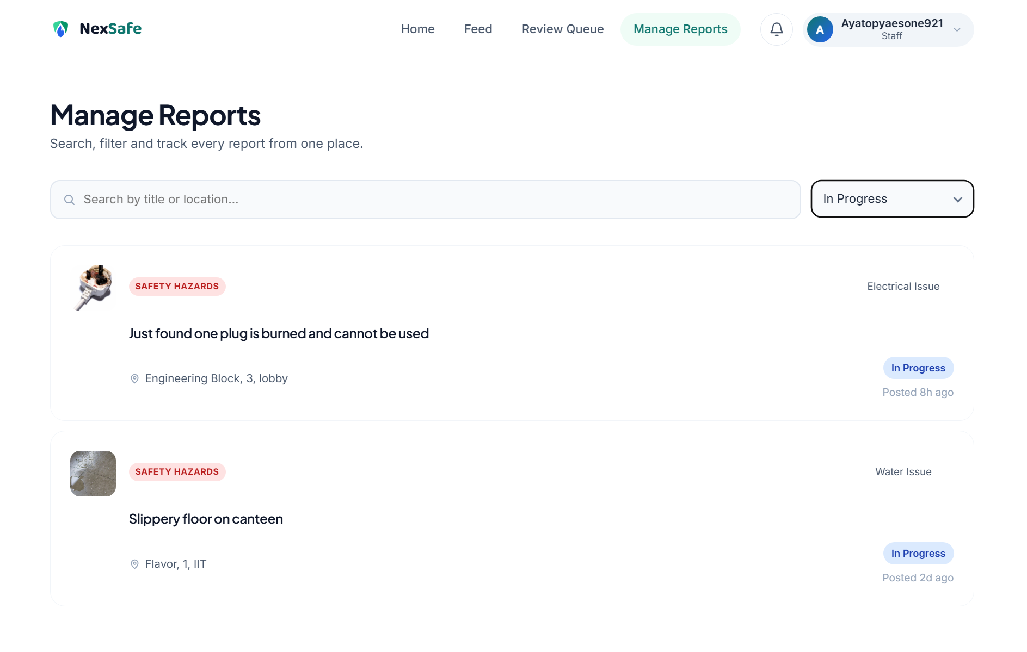
Figure 16. Manage Reports page filtered to In Progress reports.

2 Services Used
AWS service | Role in NexSafe | Main dependency / interaction
Amazon S3 | Stores static website files, Rekognition datasets and uploaded report images. | CloudFront reads private website/data objects; Rekognition reads uploaded images.
AWS Rekognition Custom Labels | Classifies five campus issue types from uploaded images. | Analyse Image Lambda supplies an S3Object and model version ARN.
AWS Lambda | Two backend functions: report CRUD/SNS and image upload/Rekognition. | Invoked by API Gateway; connects to RDS, S3, Rekognition and SNS.
Amazon API Gateway | HTTPS HTTP API used by JavaScript fetch () calls. | Routes protected requests to Lambda; JWT identity is supplied through the authorizer context.
Amazon RDS MySQL | Persistent structured report storage. | Reports Lambda connects using DB_* environment variables and mysql2/promise.
Amazon Cognito | Authentication and role groups: students and staff. | Browser uses ID token; API requests send Authorization: Bearer <token>.
Amazon SNS | Asynchronous notification publishing for staff and students. | Reports Lambda publishes to topic ARNs stored in environment variables.
Amazon Location Service | Provides map style and issue pinning for student/staff views. | Map Libre loads the AWS map style; selected coordinates are stored with the report location.
Amazon CloudFront | Final HTTPS delivery endpoint for website and private S3 image content. | S3 bucket policies allow s3: Get Object only to the configured CloudFront distribution.
AWS IAM | Controls service-to-service permissions. | Required for Lambda access to dependent services and CloudFront-restricted S3 access.

3 Development of AWS Rekognition
3.1 Objective and Custom Label Design
Generic object labels are not sufficient for NexSafe because the application needs issue-specific verification. A Custom Labels project named NexSafe-Hazard-Classifier was therefore trained for five classes that map directly to the user-facing issue options: electrical -> Electrical Issue, staircase -> Staircase Issue, water -> Water Issue, chair -> Broken Chair, and desk -> Broken Table or Desk. The Other category is intentionally not mapped to a trained class and is sent for manual staff review.
3.2 Dataset Preparation and S3 Organisation
The training and testing images were organised in S3 by class. The supplied evidence shows five folders under both dataset/train/ and dataset/test/. This structure made the intended class membership explicit before the data was used by the Custom Labels project.
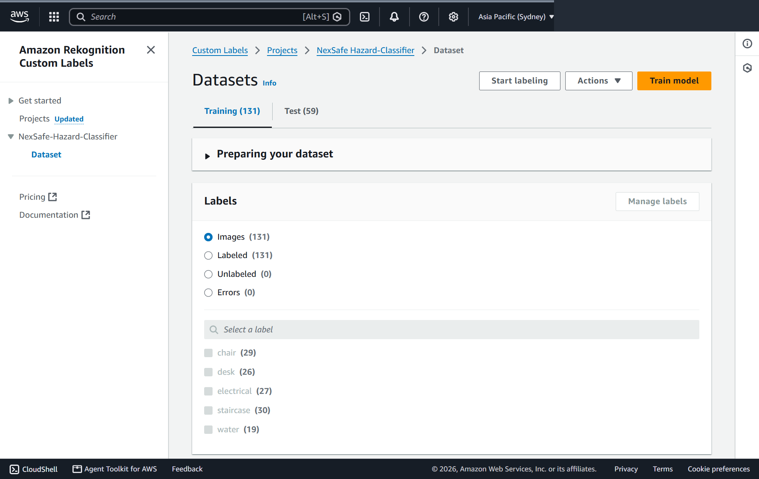
Figure 17. Rekognition training dataset: 131 labelled images across five classes.
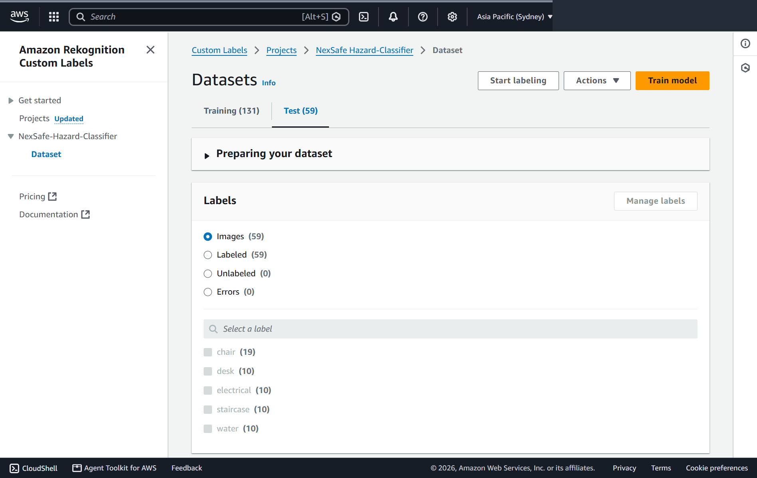
Figure 18. Rekognition testing dataset: 59 labelled images across the same five classes.

3.3 Model Training and Evaluation
The Custom Labels model was trained on 12 August 2026. The evaluation result shows an overall F1 score of 0.975, average precision of 0.972 and overall recall of 0.980. These metrics indicate that the trained model achieved strong performance on the held-out testing images used in the project.
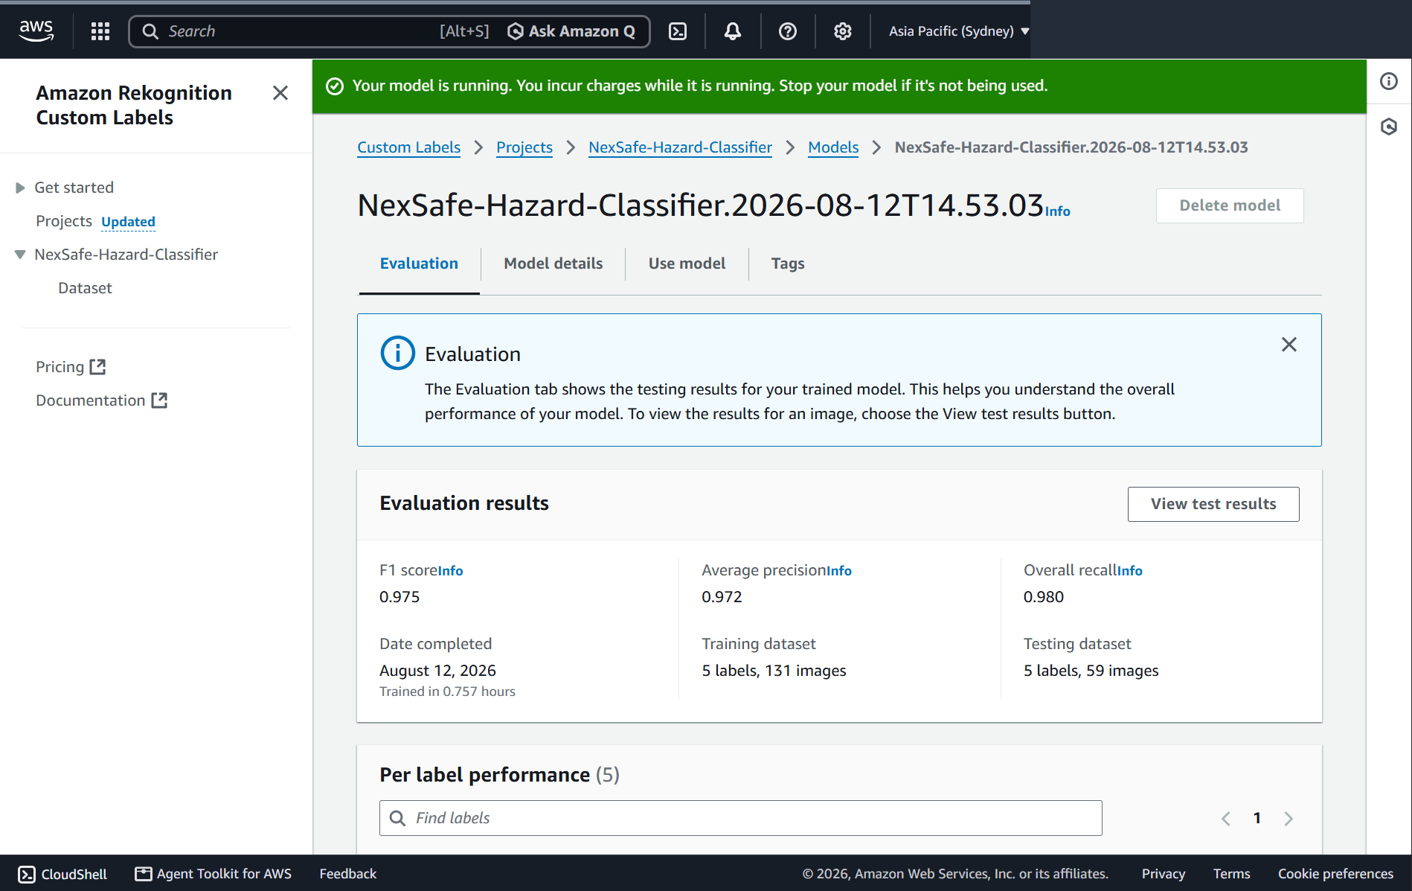
Figure 19. Rekognition model evaluation summary.
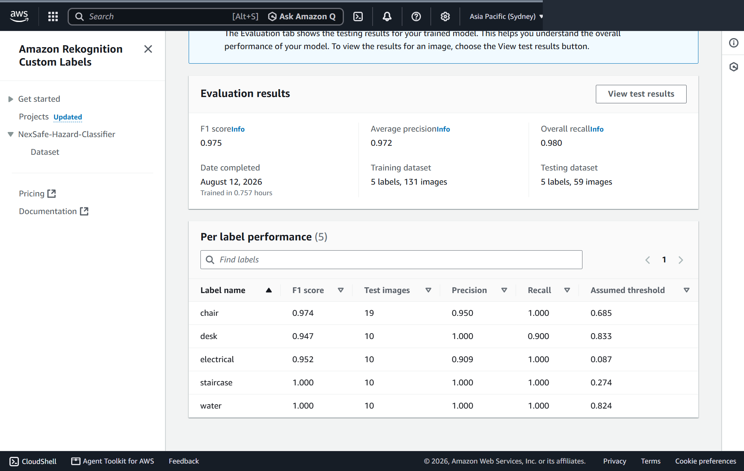
Figure 20. Per-label F1 score, precision, recall and assumed threshold.

The model-level and per-label metrics were used as a validation checkpoint before integration. Staircase and water achieved perfect F1/precision/recall on the provided test set, while desk had the lowest F1 score (0.947). This makes the evaluation useful not only as proof that the model trained successfully, but also as guidance for future dataset expansion.
3.4 Starting the Model for Inference
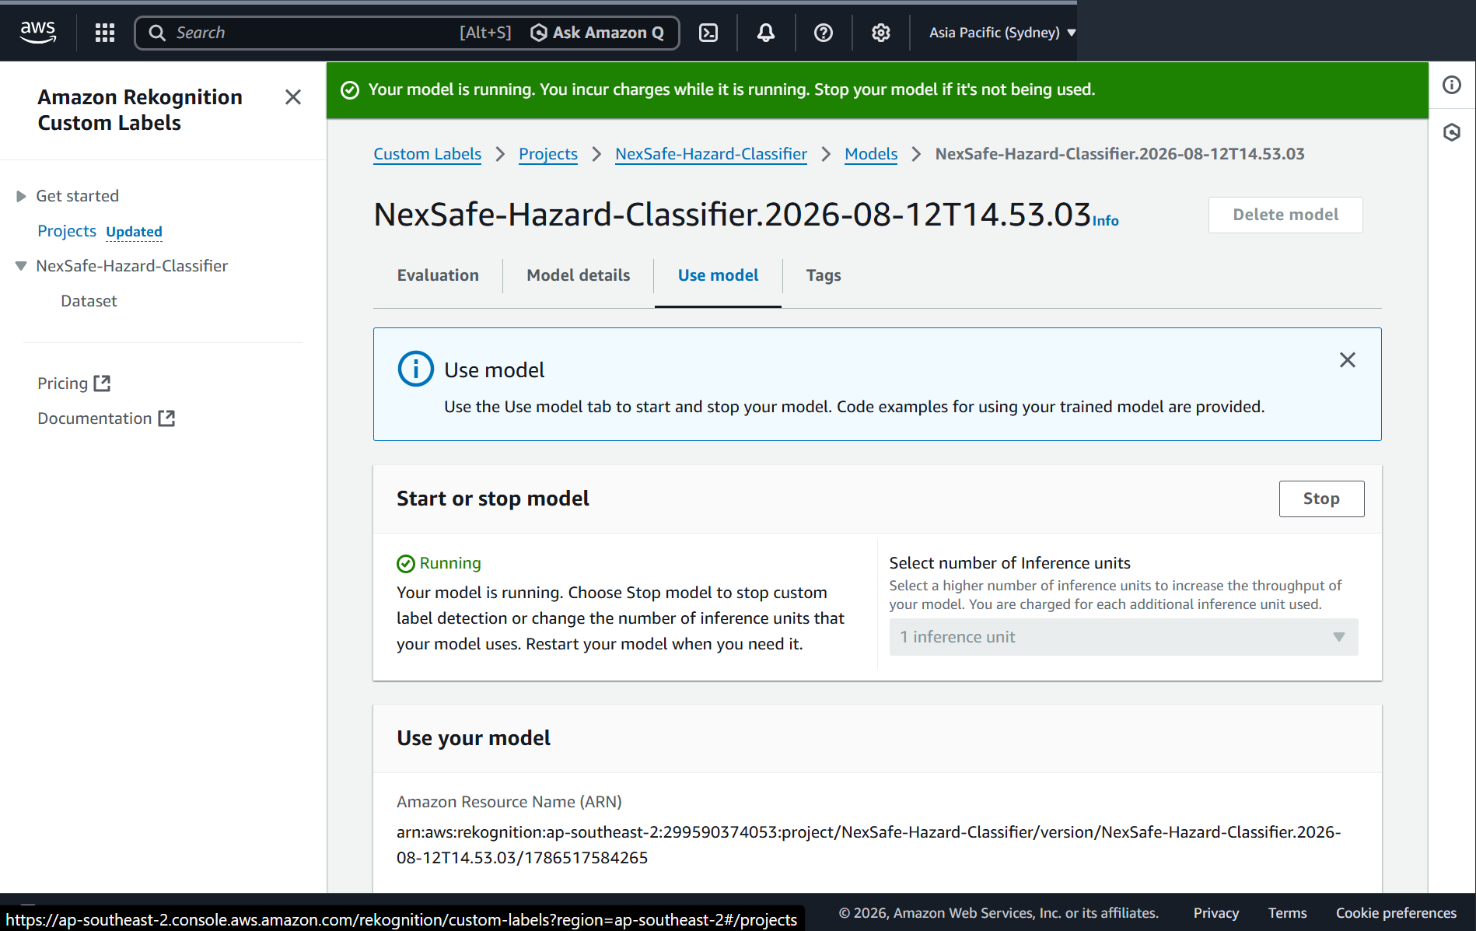
Figure 21. Custom Labels model running with one inference unit and project-version ARN available for integration.
The trained project version must be in the RUNNING state before DetectCustomLabels requests can succeed. The evidence shows the model running with one inference unit. The project-version ARN is provided to the Analyze Image Lambda through the REKOGNITION_MODEL_ARN environment variable rather than being embedded repeatedly in the request logic.
3.5 Image Input Handling in the Application
The browser does not call Rekognition directly. The student-selected file is read by the front end, converted into Base64 and sent to POST /analyze-image with an authenticated API request. The Analyze Image Lambda accepts either a new imageBase64 payload or an existing imageKey. Supported content types are JPEG, PNG and WEBP; empty or invalid Base64 data is rejected; and the function limits an uploaded image to 5 MB.

Source excerpt - S3 upload followed by Custom Labels inference
result = (
rekognition
.detect_custom_labels(
ProjectVersionArn=(
REKOGNITION_MODEL_ARN
),
MinConfidence=(
MIN_CONFIDENCE
),
Image={
"S3Object": {
"Bucket": UPLOAD_BUCKET,
"Name": image_key
}
}
)
)

3.6 Output Handling and Category Matching
Rekognition returns a list of Custom Labels. The Lambda sorts the results by Confidence in descending order and returns the highest-confidence label to the front end together with imageKey and image URL. The application maps the model label back to a user-facing issue type and compares it with the student selection.
Output field | Meaning
success | Whether the Lambda request completed successfully.
uploaded | Confirms that the photo exists in S3.
detected | True when a Custom Labels prediction is available.
label | Highest-confidence Custom Labels class.
confidence | Confidence rounded to two decimal places.
imageKey | S3 key reused during later report submission.
imageUrl | Display/reference URL for the uploaded image.

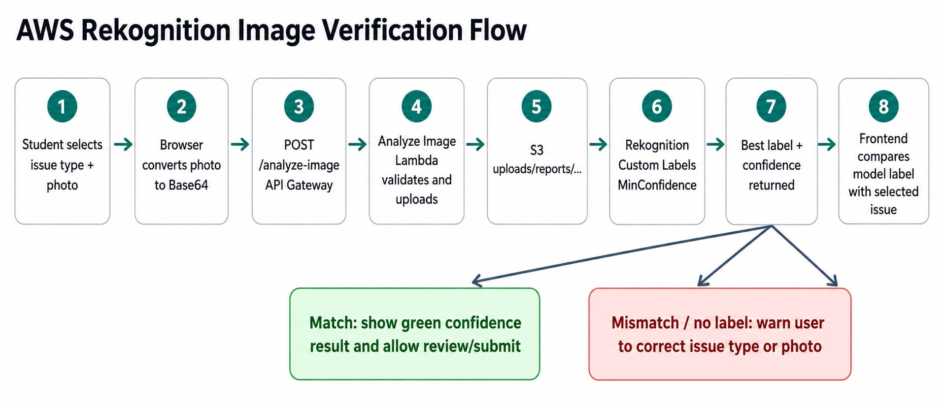
Figure 22. End-to-end image verification flow from the browser to Rekognition and back.
Figure 23. Integrated website output showing a successful 99.91% Staircase Issue match.
3.7 Performance Optimisation and Reliability Decisions
- Configurable confidence threshold: MIN_CONFIDENCE is read from a Lambda environment variable with a default of 60, allowing the acceptance floor to be adjusted without changing source code.
- Highest-confidence result: labels are sorted by Confidence and only the best candidate is used for the front-end decision, keeping the response small and deterministic.
- Image reuse: after a photo is first uploaded, the front-end reuses imageKey rather than resending the same large Base64 payload if verification is repeated.
- Upload-only path for Other: manual-review reports still store their photo but skip an unnecessary Rekognition call.
- 5 MB limit and format validation: oversized or unsupported input is rejected before inference, reducing invalid processing.

- One inference unit: the running-model evidence shows one unit, suitable for the prototype workload while avoiding unnecessary additional inference capacity.
- Model evaluation before deployment: F1, precision and recall were reviewed for all five labels instead of relying only on a successful training status.
3.8 Rekognition Error Handling and Troubleshooting
Symptom | Likely check / corrective action
HTTP 500: REKOGNITION_MODEL_ARN missing | Set the trained project-version ARN in the Analyze Image Lambda environment variables.
No label returned | Confirm the model is RUNNING, verify MIN_CONFIDENCE is appropriate, and test with an image that represents one of the five trained classes.
Invalid Base64 / empty image | Verify File Reader output and that the JSON body contains imageBase64 only after the Data URL prefix is removed.
Unsupported image type | Use JPEG, PNG or WEBP. The Lambda rejects unsupported content types before uploading.
Image larger than 5 MB | Resize/compress the input before retrying; the Lambda intentionally blocks larger payloads.
Duplicate S3 images after repeated verification | Reuse the returned imageKey. The front-end logic already supports this optimisation.
Other-category report appears to have no AI label | Expected behaviour: upload Only stores the photo for manual review and intentionally bypasses Custom Labels.

4 Development of Additional AWS Services
4.1 Amazon Cognito - Authentication and Role Separation
NexSafe uses an Amazon Cognito User Pool in ap-southeast-2. The front end sends InitiateAuth requests to the Cognito IDP endpoint. After sign-in, the ID token is decoded and checked for the expected issuer, audience and expiry. The Cognito: groups claim determines whether the account belongs to students or staff, which controls the navigation and role label shown in the interface.
Security is also enforced on the backend. Each API request includes Authorization: Bearer <Cognito ID token>. The Reports Lambda reads claims supplied in the API Gateway authorizer context. POST /reports ignores any author identity sent by the browser and replaces it with the authenticated Cognito email/name. PUT and DELETE are rejected unless Cognito: groups contain staff. This prevents the user interface alone from being the security boundary.

var groups = claims["cognito:groups"] || [];

if (groups.indexOf("staff") !== -1) {
actualRole = "staff";
} else if (groups.indexOf("students") !== -1) {
actualRole = "student";
}

After Cognito authentication, NexSafe decodes the ID token and reads the cognito: groups claim to determine whether the authenticated account belongs to the students or staff group. This controls the appropriate user interface presented to the user.
4.2 Amazon SNS - Notification Publishing
The Reports Lambda creates an SNSClient in the application region and reads two topic ARNs from environment variables: SNS_STAFF_TOPIC_ARN and SNS_STUDENT_TOPIC_ARN. After a new report is inserted, notifyStaffOfNewReport () publishes report details for staff. When staff changes the report status or staff update text, notifyStudentOfReportUpdate () publishes a student-facing update. Notification failure is caught and logged so that an SNS publishing issue does not undo the database operation.
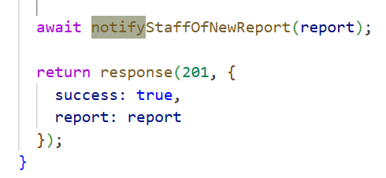
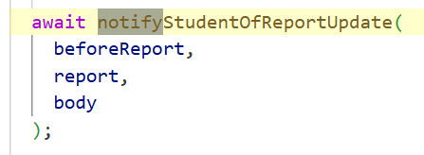

Trigger | SNS destination | Content
New report created | Staff topic | Report ID, title, issue type, category, location, author and status.
Status changed | Student topic | Report title and the new friendly status.
Staff update changed | Student topic | Latest staff update text; may be sent with a status change.
Topic ARN missing | No publish | Function warns and returns false instead of failing the report request.

4.3 Amazon Location Service - Campus Map
The Report page uses MapLibre GL with an Amazon Location Service Standard style descriptor in ap-southeast-2. The map opens around Temasek Polytechnic. When the student clicks a point, the previous marker is removed, a new marker is added, and the latitude/longitude are stored to six decimal places. During report creation these coordinates are appended to the readable location text, allowing staff to reconstruct the selected point in the review interface.

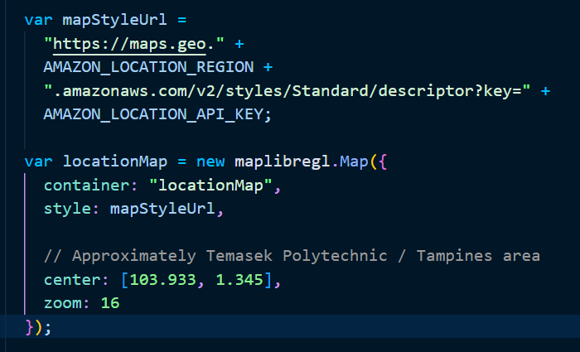

4.4 Amazon CloudFront - Secure Content Delivery
CloudFront is the final public entry point for NexSafe. The deployed distribution is enabled and provides the domain d2a0yi8f3vpirh.cloudfront.net. The evidence shows S3 origins for the website bucket and the AI/data bucket. Both S3 buckets have Block Public Access enabled, and their bucket policies grant s3:GetObject to the CloudFront service principal only when AWS:SourceArn equals the NexSafe distribution ARN. This avoids a public-read S3 policy while still allowing the application to serve the required files.
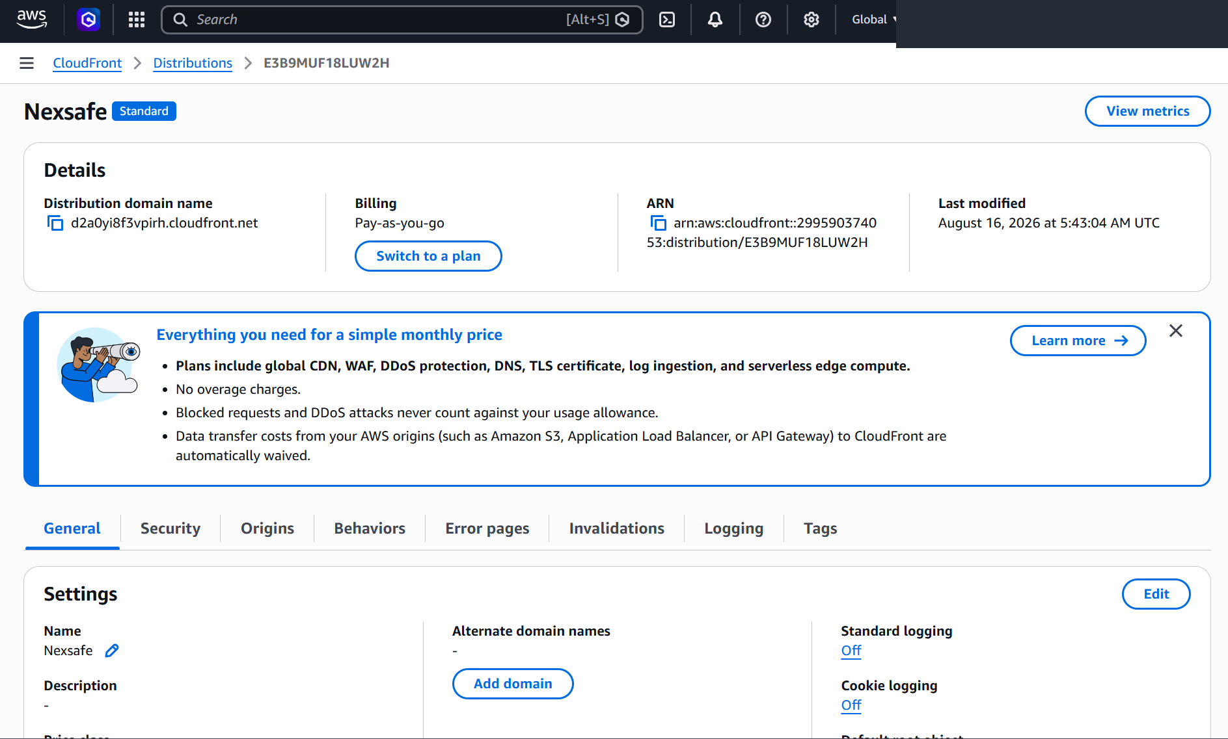
Figure 24. Enabled NexSafe CloudFront distribution and final distribution domain.
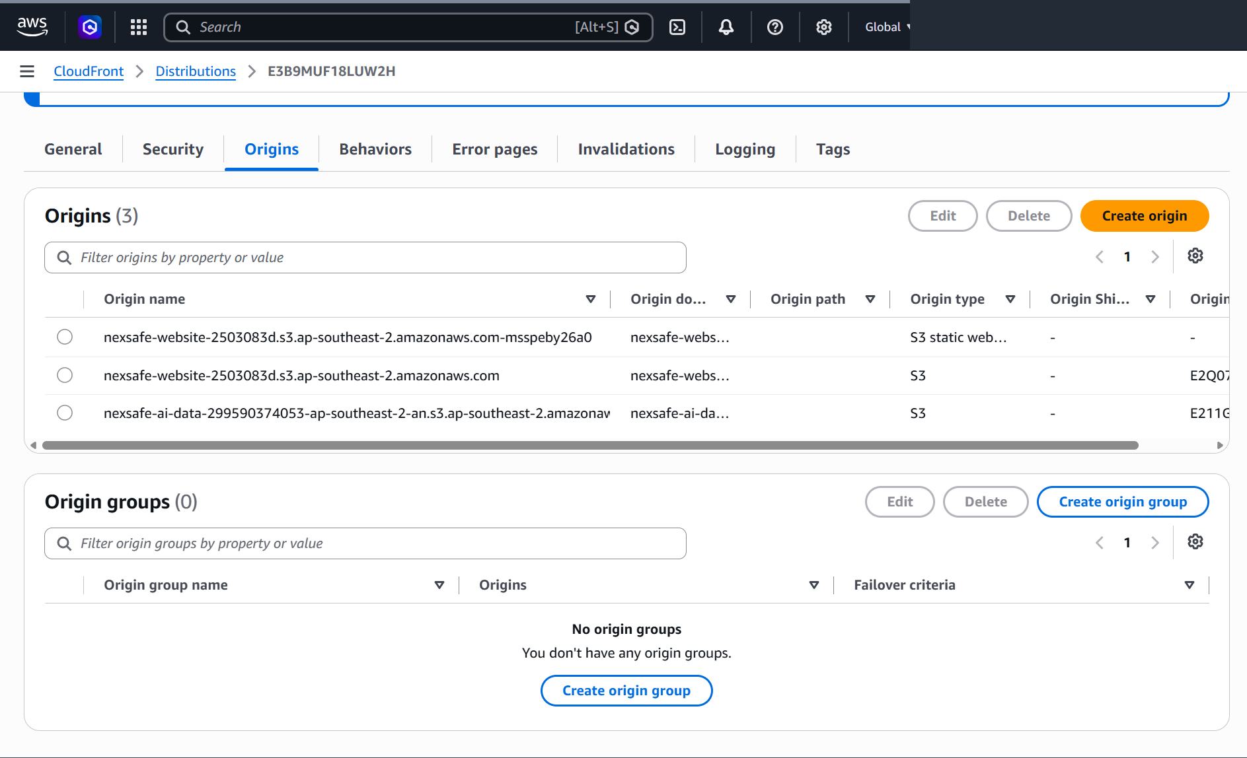
Figure 25. CloudFront origins include the website S3 bucket and AI/data S3 bucket.
S3 static website hosting remains enabled as part of the S3 deployment configuration, but the final public URL supplied for the project is the HTTPS CloudFront domain. The CloudFront-restricted bucket policies demonstrate that direct public S3 object access is not the intended final delivery path.

5 Deployment Process

This section records the deployment in an order that preserves service dependencies. The process begins with storage and model assets, then establishes backend services, authentication and API access, and finally places CloudFront in front of the S3 content. Sensitive values such as database passwords, SNS topic ARNs and the Amazon Location key are not printed in the report.
Step 1 - Prepare the Web Application
1. Confirm the complete static web application is available: index.html, auth.html, home.html, feed.html, report.html, myreports.html, review.html, manage.html, css/ and js/.
2. Confirm common.js points to the deployed API Gateway base URL and sends the Cognito ID token in the Authorization header for protected requests.
3. Keep the two Lambda functions as separate deployment units: nexsafe-analyze-image (Python) and nexsafe-reports-api (Node.js).
Step 2 - Create and Populate the Website S3 Bucket
1. Create a general-purpose S3 bucket in ap-southeast-2. The deployed bucket shown in the evidence is nexsafe-website-2503083d.
2. Upload all HTML files and the css/ and js/ directories while preserving relative paths.
3. Enable S3 static website hosting as the serverless website-hosting configuration required by the project and set the site entry document to index.html.
4. Verify the object list contains the expected front-end files before connecting CloudFront.
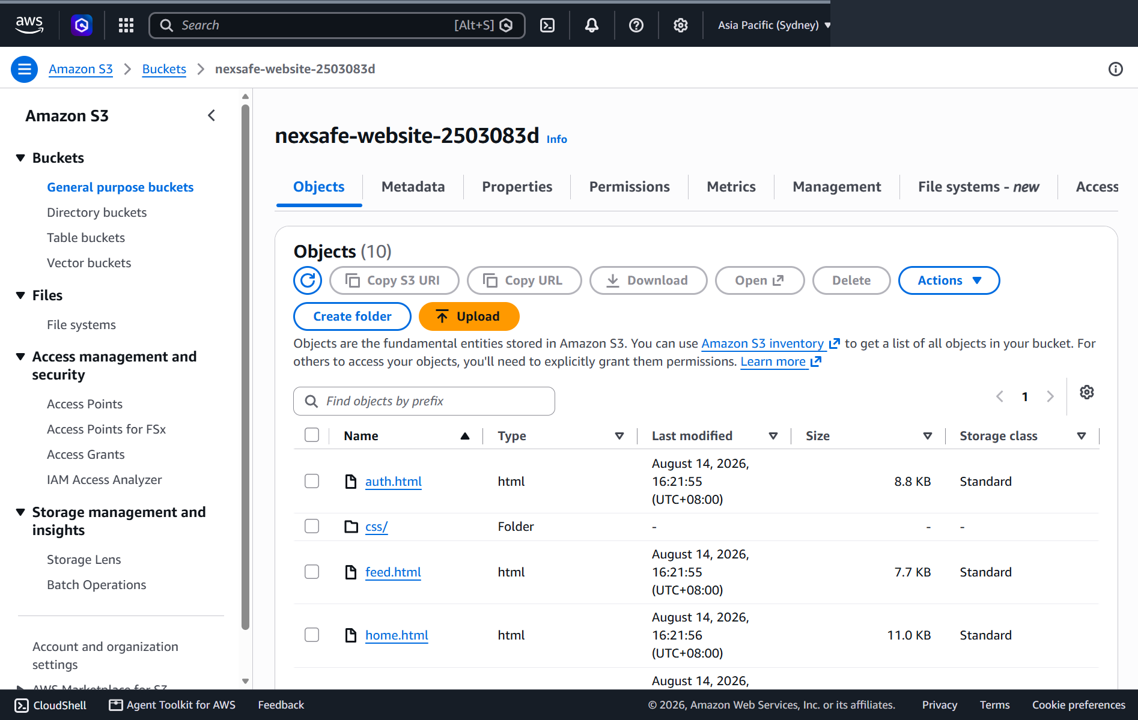
Figure 26. Website files deployed to the NexSafe S3 website bucket.
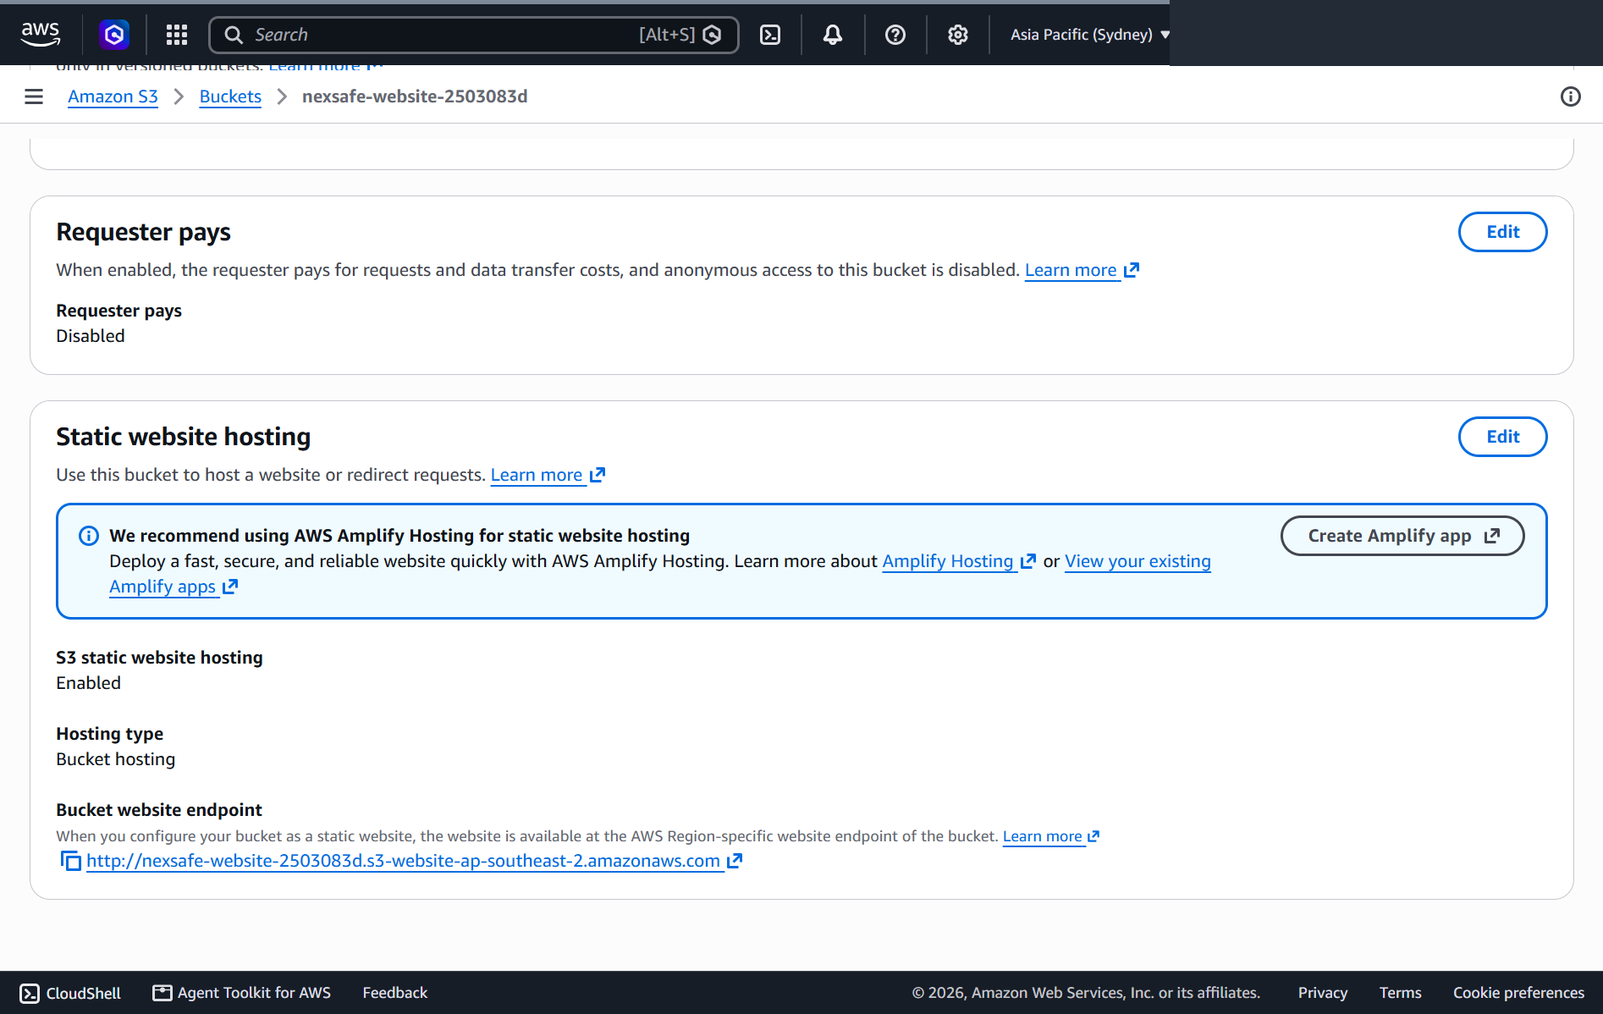
Figure 27. S3 static website hosting enabled for the website bucket.
Step 3 - Secure the Website S3 Bucket
1. Enable Block all public access on the website bucket.
2. Use a bucket policy that grants s3:GetObject to Service: cloudfront.amazonaws.com rather than to Principal: *.
3. Restrict the permission with AWS: SourceArn so that only the NexSafe CloudFront distribution can use the policy.
4. Retest the CloudFront URL after the change; do not depend on anonymous S3 object access.
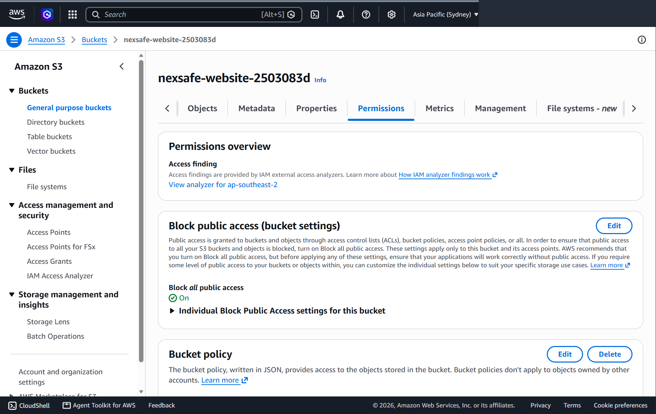
Figure 28. Website bucket with Block all public access enabled.
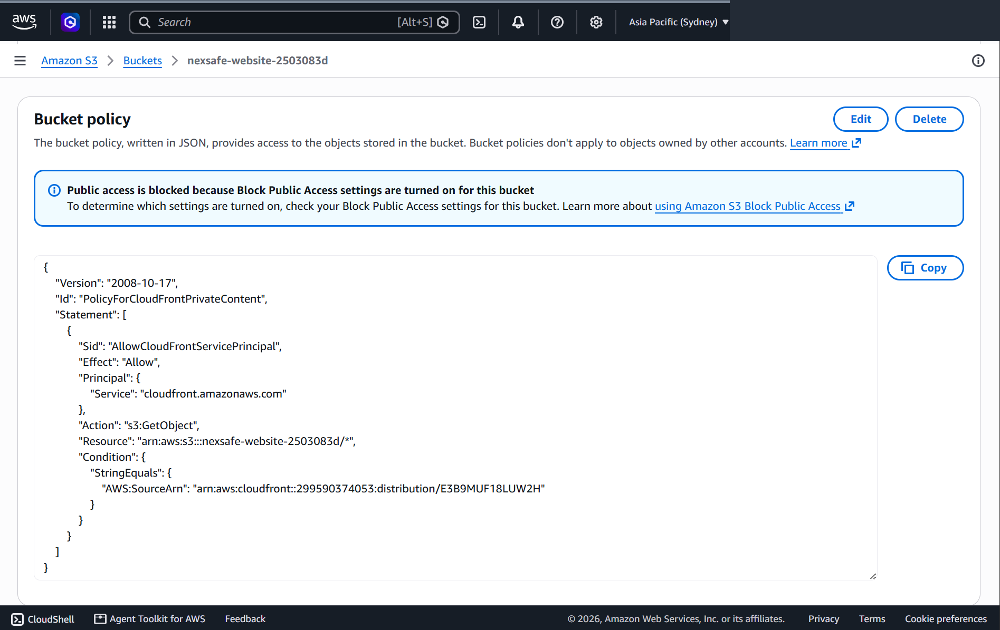
Figure 29. Website bucket policy restricted to the CloudFront service principal and distribution SourceArn.
Step 4 - Create the AI/Data S3 Bucket
- Create a separate S3 bucket for model datasets and uploaded report evidence.
- Create dataset/train/<class>/ and dataset/test/<class>/ for chair, desk, electrical, staircase and water.
- Use uploads/reports/ as the runtime image prefix. The Analyze Image Lambda further creates year/month subfolders and UUID file names.
- Enable Block all public access. Grant CloudFront read access only to uploads/reports/* where image display is required.
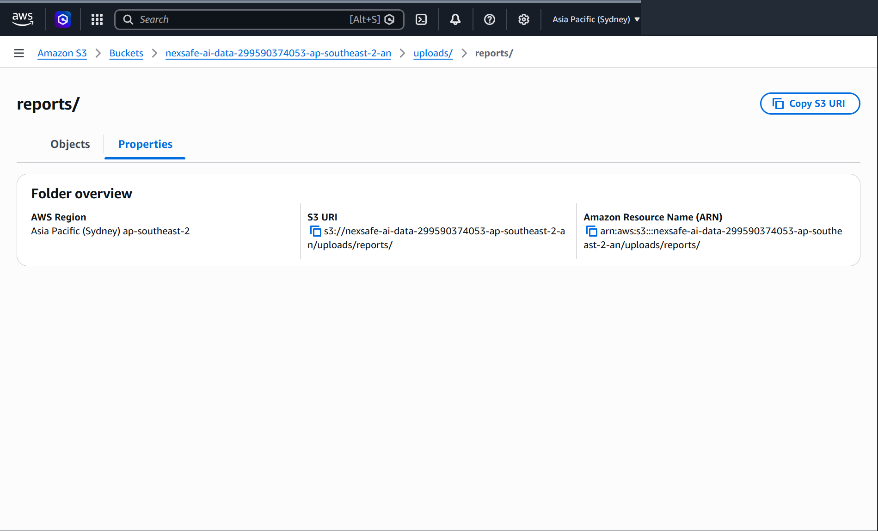
Figure 30. Runtime report-image prefix in the AI/data S3 bucket.
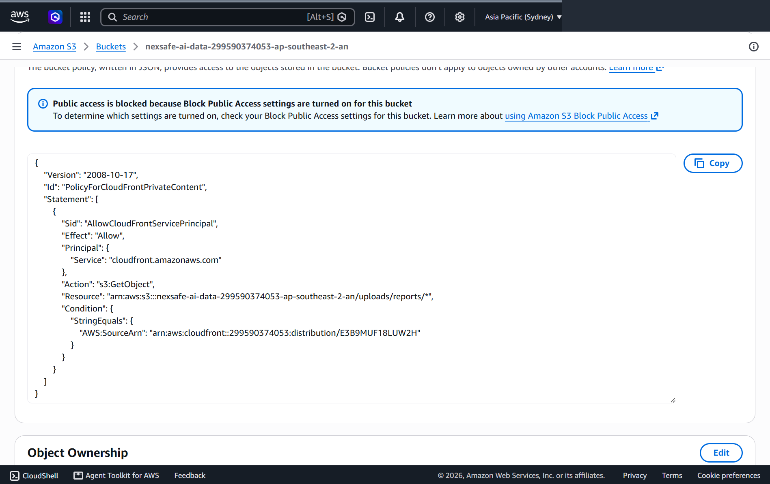
Figure 31. Data-bucket policy limits CloudFront read permission to uploads/reports/*.
Step 5 - Train and Start AWS Rekognition Custom Labels
1. Create the NexSafe-Hazard-Classifier Custom Labels project.
2. Associate the prepared training and testing images with the five labels.
3. Train a project version and review overall and per-label evaluation metrics.
4. Start the selected project version and record its ProjectVersionArn.
5. Use one inference unit for the deployed prototype shown in the evidence.
Step 6 - Configure the Analyze Image Lambda
Setting | Value / source
Runtime | Python (source file nexsafe-analyze-image.txt)
AWS_REGION | ap-southeast-2
UPLOAD_BUCKET | NexSafe AI/data bucket name
REKOGNITION_MODEL_ARN | Running Custom Labels ProjectVersionArn
MIN_CONFIDENCE | Configurable; source default is 60
PUBLIC_IMAGE_BASE_URL | Public display base for private images, normally the CloudFront content path/domain used by the final deployment

1. Deploy the Python Lambda code and grant only the S3/Rekognition permissions required by its operations.
2. Set the environment variables above. Do not place a model ARN or bucket-specific configuration in every browser request.
3. Test a new JPEG/PNG/WEBP image. Confirm the function uploads an object under uploads/reports/ and returns label, confidence, imageKey and imageUrl.
4. Test upload Only=true for Other and confirm the object uploads without a Rekognition label.
Step 7 - Configure RDS MySQL and the Reports Lambda
The submitted source configures the Reports Lambda to connect to MySQL using DB_HOST, DB_PORT, DB_NAME, DB_USER and DB_PASSWORD. DB_PORT defaults to 3306 and DB_NAME defaults to nexsafe. The actual password and endpoint are intentionally omitted from this report.
1. Create the MySQL database and ensure the Lambda network/security configuration can reach the database endpoint on the configured port.
2. Deploy nexsafe-reports-api as a Node.js Lambda. Its source imports mysql2/promise, so the deployment package or Lambda layer must include the mysql2 package.
3. Set DB_HOST, DB_PORT, DB_NAME, DB_USER and DB_PASSWORD as Lambda environment variables.
4. Set SNS_STAFF_TOPIC_ARN and SNS_STUDENT_TOPIC_ARN for notification publishing.
5. Run a direct Lambda test without routeKey. The function returns a NexSafe RDS connection check and ensures the reports table exists.
Step 8 - Create the API Gateway HTTP API
Route | Backend action | Authorization expectation
POST /reports | INSERT a report | Authenticated Cognito user; author identity overwritten from JWT
GET /reports | SELECT reports | Authenticated request
GET /reports/mine | SELECT current user reports | Authenticated; email taken from JWT
GET /reports/{id} | SELECT one report | Authenticated request
PUT /reports/{id} | UPDATE status/priority/staff update | Staff group required by Lambda
DELETE /reports/{id} | DELETE report | Staff group required by Lambda
POST /analyze-image | S3 upload + Rekognition | Authenticated request

- Create an HTTP API and integrate the six report routes with the Reports Lambda and /analyze-image with the Analyze Image Lambda.
- Use the dev stage shown by the deployed front-end base URL: https://g7t2m0em5d.execute-api.ap-southeast-2.amazonaws.com/dev.
- Configure the Cognito-compatible JWT authorizer so protected requests supply validated claims to requestContext.authorizer.jwt.claims.
- Configure browser CORS for the website origin/methods/headers required by the front end; the Lambda JSON responses also include an Access-Control-Allow-Origin response header.
- Update common.js AWS_API_BASE only after the stage URL is confirmed.
Step 9 - Configure Cognito, SNS and Amazon Location
- In Cognito, create/use the NexSafe User Pool and app client, then create students and staff groups. Add test users to the appropriate group.
- In SNS, create the logical staff and student topics/subscriptions and set their ARNs in the Reports Lambda environment variables.
- In Amazon Location Service, configure the map style/API-key resource for browser map use in ap-southeast-2. Restrict the key to the intended map/application usage and do not publish the full key in documentation.
- Test student and staff logins separately and confirm the expected navigation is visible for each role.
Step 10 - Create the CloudFront Distribution
- Create an enabled CloudFront distribution and add the S3 website content and AI/data content as origins required by the application.
- Use private S3 access rather than anonymous public-read bucket policies. Apply the CloudFront service-principal bucket policies shown earlier.
- Set the default root object/website entry to index.html for the front-end entry point.
- Use the final HTTPS CloudFront URL for testing and submission: https://d2a0yi8f3vpirh.cloudfront.net/.
- After changing website objects, invalidate or refresh cached objects as necessary during final verification.
Step 11 - End-to-End Verification
- Open the CloudFront URL and verify the landing page and role-specific authentication.
- Sign in as a student, create a report, select a map point and upload a trained-class image.
- Confirm a real Rekognition label/confidence is displayed, then complete the review and submit the report.
- Confirm the new report appears in Feed and My Reports.
- Sign in as staff, confirm the new report appears in Review Queue, then set priority/status and enter a staff update.
- Return to the student account and verify the changed status/notification.
- Test Manage Reports filtering and staff-only update/delete access.
Advanced Troubleshooting Guide
Problem | Diagnosis | Resolution
CloudFront page loads but report images show AccessDenied | Data bucket is private and the CloudFront policy/path does not match the image object. | Check the policy Resource includes uploads/reports/* and AWS:SourceArn matches the active distribution. Ensure PUBLIC_IMAGE_BASE_URL points to the final display path rather than a blocked direct S3 URL.
401 from API Gateway / API | ID token missing, expired, wrong issuer/audience or authorizer not attached. | Re-authenticate, inspect localStorage token presence, verify Cognito issuer/app client and route authorizer configuration.
403 on PUT/DELETE | Authenticated user is not in staff group. | Assign the account to the Cognito staff group. The Lambda intentionally rejects non-staff updates/deletes.
Reports Lambda: Missing database environment variables | DB_HOST, DB_USER or DB_PASSWORD not configured. | Set the required DB_* environment variables; keep credentials out of source code.
Reports Lambda cannot load mysql2/promise | mysql2 dependency is absent from the deployed Node.js artifact. | Include mysql2 in the Lambda deployment package or an attached Lambda layer.
Database connection timeout | Network/security path to the RDS endpoint is unavailable or endpoint/port is incorrect. | Verify DB_HOST/DB_PORT and the Lambda/RDS network and security-group rules.
POST /analyze-image returns model ARN error | REKOGNITION_MODEL_ARN missing. | Set the ARN of the trained project version and restart/start the model as required.
Rekognition returns no label | Model is stopped, confidence floor is too high, or the image is outside the trained domain. | Verify RUNNING status, evaluate MIN_CONFIDENCE and test against the five supported classes.
SNS email/update is missing but report still saves | Topic ARN is empty or publish failed. | Check SNS_STAFF_TOPIC_ARN / SNS_STUDENT_TOPIC_ARN and subscription confirmation. The code intentionally does not roll back the report operation when SNS publishing fails.
Location map does not render | MapLibre library/key/region/style URL issue. | Verify the MapLibre assets load, the Amazon Location region is ap-southeast-2, and the browser key is valid for the intended map resource.
API route returns 404 Route not found | API Gateway route/stage does not match the routeKey handled by Lambda. | Compare the configured method/path with the exact switch cases in the Reports Lambda and redeploy the stage if necessary.

6 Setup Guide for AWS Services
This section is a reference-oriented configuration guide. Unlike the chronological deployment process, it summarises what each service must contain, why it is needed and which other NexSafe component depends on it.
Amazon S3
Resource | Key configuration | Interaction
Website bucket: nexsafe-website-2503083d | ap-southeast-2; HTML/CSS/JS objects; static website hosting enabled; Block Public Access on; CloudFront-only GetObject policy. | CloudFront retrieves static front-end objects.
AI/data bucket | dataset/train, dataset/test and uploads/reports prefixes; Block Public Access on; CloudFront GetObject policy limited to uploads/reports/*. | Analyze Image Lambda writes report images; Rekognition reads them; CloudFront displays allowed report images.
Object ownership | Bucket owner enforced shown for data bucket. | Prevents ACL-based public access from being the normal permission mechanism.

AWS Rekognition Custom Labels
Configuration | NexSafe value
Project | NexSafe-Hazard-Classifier
Region | ap-southeast-2
Labels | chair, desk, electrical, staircase, water
Training set | 131 images
Testing set | 59 images
Model result | F1 0.975; average precision 0.972; recall 0.980
Runtime | RUNNING; 1 inference unit in evidence
Lambda configuration | REKOGNITION_MODEL_ARN + MIN_CONFIDENCE

AWS Lambda - Analyze Image
Responsibility | Implementation detail
Validate input | JSON body; JPEG/PNG/WEBP; Base64 validation; 5 MB maximum.
Create object key | uploads/reports/YYYY/MM/<uuid>. <extension>.
Store evidence | s3.put_object to UPLOAD_BUCKET.
Run model | rekognition. detect_custom_labels with ProjectVersionArn and MinConfidence.
Choose output | Sort CustomLabels by Confidence and return highest result.
Manual path | uploadOnly=true bypasses classification for Other.
Failure response | JSON 400 for invalid JSON; JSON 500 for configuration/runtime failures.

Amazon RDS MySQL
The Reports Lambda creates the reports table if it does not already exist. The table includes indexes on author_id, status and created_at to support the main retrieval/filtering patterns. Database connection values are provided through environment variables rather than hardcoded credentials.
Column / index | Purpose
id BIGINT AUTO_INCREMENT PK | Stable report identifier.
title, issue_type, category | Main report classification fields.
building, level, exact_location, location | Human-readable location and map-coordinate representation.
description | Student description.
status, priority | Workflow management.
author_id, author_name | Bound to authenticated Cognito identity on create.
image LONGTEXT | Stores S3/CloudFront image reference rather than Base64 bytes.
rekognition JSON | Stores verification result metadata.
staff_update | Message shown to the submitting student.
created_at, updated_at | Audit timing.
idx_author_id, idx_status, idx_created_at | Indexes supporting student/report status/time retrieval.

AWS Lambda - Reports API
The Reports Lambda opens a MySQL connection, ensures the table exists, reads event.routeKey and dispatches to create/list/read/update/delete functions. Direct Lambda test events are also supported before API Gateway integration.
Source excerpt - database configuration through environment variables
const dbHost = process.env.DB_HOST;
const dbPort = Number(process.env.DB_PORT || 3306);
const dbName = process.env.DB_NAME || "nexsafe";
const dbUser = process.env.DB_USER;
const dbPassword = process.env.DB_PASSWORD;
connection = await mysql.createConnection({
host: dbHost, port: dbPort, user: dbUser,
password: dbPassword, database: dbName, connectTimeout: 10000
});

Amazon API Gateway
The front end uses one deployed HTTP API base URL with the dev stage. common.js sends authenticated requests to the routes listed below. The Cognito ID token is passed in the Authorization header. API Gateway validates the JWT before the protected Lambda logic is executed, while the Lambda additionally enforces staff-only operations using the group claim.
Front-end operation | Route | Expected result
List Feed | GET /reports | Array of normalised report objects.
My Reports | GET /reports/mine | Only reports belonging to the authenticated user.
View detail | GET /reports/{id} | One report.
Submit report | POST /reports | Inserted report with database-generated ID.
Staff update | PUT /reports/{id} | Updated status/priority/staff message.
Staff delete | DELETE /reports/{id} | Deletion response.
Verify/upload image | POST /analyze-image | Rekognition label/confidence and S3 image reference.

Amazon Cognito
Configuration | Purpose
Region | ap-southeast-2
User Pool ID | Configured in the submitted front end; exact value available in source code.
App client ID | Configured in the submitted front end; used as JWT audience.
Groups | students and staff
Client token storage | ID/access/refresh token values are retained in localStorage for this prototype.
API header | Authorization: Bearer <ID token>
Backend use | JWT email/name identify author; cognito:groups controls staff privileges.

Amazon SNS
Environment variable | Usage
SNS_STAFF_TOPIC_ARN | Publish a new-report notification after successful creation.
SNS_STUDENT_TOPIC_ARN | Publish status/staff-update notifications after staff changes.
AWS_REGION | SNS client region; source defaults to ap-southeast-2.

Amazon Location Service
Element | Implementation
Region | ap-southeast-2
Client map library | MapLibre GL 5.x
Map style | Amazon Location v2 Standard style descriptor
Initial map position | Approximately Temasek Polytechnic / Tampines; zoom 16
Interaction | Click records longitude/latitude, removes old marker and places a new marker.
Staff view | Saved coordinates are parsed and used to recreate a marker in the report modal.

Amazon CloudFront and S3 Security
Configuration | Evidence / purpose
Distribution | Nexsafe; enabled; final domain d2a0yi8f3vpirh.cloudfront.net.
Origins | Includes S3 website and AI/data bucket origins.
Website S3 policy | CloudFront service principal may GetObject only when SourceArn matches distribution E3B9MUF18LUW2H.
Data S3 policy | Same distribution restriction, with Resource limited to uploads/reports/*.
Block Public Access | On for both website and data buckets.
Final URL | HTTPS CloudFront URL supplied for project submission.

Service Interaction Summary
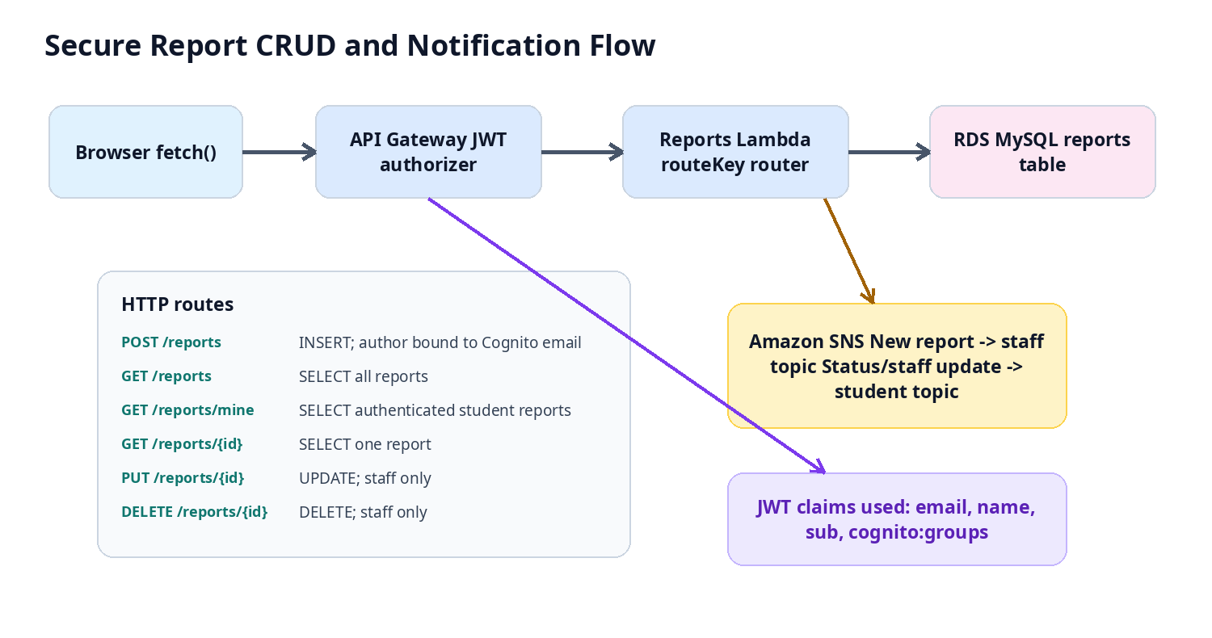
Figure 32. Protected CRUD, JWT authorization and SNS notification interactions.
The strongest security control is the combination of multiple layers rather than a single check: CloudFront-restricted S3 policies protect static/image data, Cognito establishes identity, API Gateway performs JWT authorization before Lambda, and the Reports Lambda still checks the staff group before allowing update/delete. Database credentials and service ARNs are supplied as environment variables instead of being sent by the browser.

7 Testing, Security and Validation
Functional Validation
Test | Observed evidence
Student authentication | Student sign-in screen and authenticated student dashboard.
Staff role | Staff dashboard and role chip; staff-only Review Queue / Manage Reports pages.
Map input | Selected coordinates displayed after map click.
Real Rekognition integration | Staircase image matched to Staircase Issue at 99.91% confidence.
Create | New report appears immediately in Feed/My Reports.
Read | Feed and My Reports display stored report data.
Update | Staff modal exposes status, priority and staff update; resolved state shown.
Delete | Staff-only Delete this report action is present and backend route is staff-gated.
Filter | Feed category filters and Manage Reports status filter alter displayed records.
Notifications | Student and staff notification interfaces display report events.

Cloud Security Controls
  - Both displayed S3 buckets use Block all public access.
  - CloudFront, not anonymous users, is the allowed principal in the bucket policies.
  - The data-bucket CloudFront policy is scoped to uploads/reports/*, reducing unnecessary read scope.
  - API requests carry a Cognito token and backend authorization does not trust browser-supplied report author identity.
  - Only members of the staff group can execute report update and delete in the backend Lambda.
  - Database password and service topic ARNs are environment configuration and are not included in browser requests or this report.
  - Uploaded report images are stored as S3 object references in RDS; Base64 image bytes are not stored in the report table.
  - Parameterized database execute () calls are used for ID-based operations, reducing the need to construct SQL from raw request strings.
  - Analyze Image Lambda is granted only the S3 and Rekognition permissions required for image upload and analysis.
  - Reports Lambda is granted only the permissions required for its dependent AWS services such as SNS publishing.
  - S3 read permission is restricted to the required CloudFront distribution using AWS:SourceArn, rather than allowing public access.
8 Conclusion and Future Improvements

NexSafe demonstrates a complete AWS-based campus issue reporting workflow. Students authenticate, identify the issue and location, upload photographic evidence and receive a real AWS Rekognition Custom Labels verification before submission. Reports are persisted in MySQL through a serverless API, displayed dynamically in the feed, and managed by staff through status, priority and update controls. The solution also extends the required services with Cognito, SNS, Amazon Location Service and CloudFront.
The deployment shows security improvements beyond a basic public S3 website. The website and report-image buckets have Block Public Access enabled, while CloudFront-specific bucket policies provide controlled read access. Authentication identity is propagated through JWT claims, and staff-only operations are rechecked inside the backend rather than depending only on hidden navigation controls.
Future work can focus on expanding the Custom Labels dataset and adding more campus issue classes, especially where class counts are lower or evaluation metrics are weaker than the strongest labels. The operational workflow could also be extended with maintenance-team assignment, escalation rules and richer resolution history.

References

- https://docs.aws.amazon.com/rekognition/latest/customlabels-dg/what-is.html
- https://docs.aws.amazon.com/apigateway/latest/developerguide/welcome.html
- https://docs.aws.amazon.com/AmazonS3/latest/userguide/Welcome.html
- https://docs.aws.amazon.com/AmazonRDS/latest/UserGuide/CHAP_MySQL.html
- https://docs.aws.amazon.com/secretsmanager/latest/userguide/intro.html
- https://docs.aws.amazon.com/cognito/latest/developerguide/what-is-amazon-cognito.html

